烟幕干扰弹投放策略优化建模
2025 年高教社杯全国大学生数学建模竞赛 A 题

摘要
烟幕干扰弹通过在来袭导弹与保护目标之间构建烟幕遮蔽以削弱其末段制导能力，合理设计无人机航向、速度与干扰弹投放/起爆时序是延长有效遮蔽时间的关键。本文以假目标为原点建立空间直角坐标系，构建了涵盖无人机—干扰弹—云团—导弹的几何运动学模型，以导弹与真目标中心的视线是否被有效云团球体（半径 10 m，起爆后 20 s 内有效，以 3 m/s 匀速下沉）遮挡为判据，将有效遮蔽时长定义为遮蔽指示函数的时间积分，并通过时间采样与边界二分精化高精度求值。针对参数可行域占比极小的困难，引入逆向运动学初始化将四维投放参数映射为”目标遮蔽时刻—视线位置—起爆时刻”的几何构造，配合全局差分进化（逆向候选播种种群）与坐标轮换爬山实现单弹准全局搜索；多弹问题采用”增量贪心（逐弹最大化新增遮蔽）+ 全局轮换精修”实现遮蔽窗口在时间轴上的无缝拼接；多机多目标问题对每枚导弹独立执行上述流程后统一协调同机约束并逐弹精修。求解引擎以 C# 实现（单轮全流程计算约 20 分钟），并经多种子独立重启与统计收敛验证确保结果稳定。
针对问题一，给定策略（θ=180°、120 m/s、1.5 s 投放、3.6 s 起爆）下 M1 的有效遮蔽时长为 1.4351 s，遮蔽区间 [8.013, 9.448] s，且经 C# 与 Python 双引擎交叉验证一致。针对问题二，优化得到 FY1 最优策略 θ=6.35°、v=132.24 m/s、t_drop=0.141 s、Δt=0.653 s，单弹遮蔽时长提升至 4.8258 s（12 次独立准全局搜索均值 4.789 s、标准差 0.067 s），约为问题一的 3.4 倍。针对问题三，FY1 投放 3 枚干扰弹经增量贪心与轮换精修，遮蔽区间在时间轴无缝拼接，有效遮蔽时长达到 11.2988 s。针对问题四，FY1、FY2、FY3 各投放 1 枚干扰弹，三机在导弹视线走廊不同区段协同遮蔽，有效遮蔽时长达到 15.5128 s。针对问题五，5 架无人机（每架至多 3 枚）对三枚导弹干扰，增量贪心与全局协调选中 13 枚有效弹，M1、M2、M3 遮蔽时长分别为 20.012 s、24.085 s、17.773 s，总遮蔽时长 61.870 s，全部方案通过速度范围、同机投放间隔（≥1 s）与弹数约束回代校验。敏感性分析表明遮蔽时长对航向角与投放时刻最敏感，对速度与起爆间隔稳健，最优解对 ±5% 参数扰动稳健。
关键词：烟幕干扰弹；投放策略；视线遮挡；逆向运动学初始化；差分进化；分层优化

一、问题重述

1.1 问题背景
烟幕干扰弹通过化学燃烧或爆炸形成烟幕云团，在来袭武器与保护目标之间形成遮蔽，干扰敌方导弹的末段制导，具有成本低、效费比高的优点。随着定点精确抛撒技术的发展，无人机可挂载烟幕干扰弹巡飞待机，受领任务后按预定时序投放并起爆，在导弹视线方向上构建烟幕遮蔽。合理设计无人机的航向、速度以及干扰弹的投放点与起爆点，是延长有效遮蔽时间的关键。

1.2 问题提出
现以假目标为原点建立空间直角坐标系，真目标为底面圆心位于 (0, 200, 0)、半径 7 m、高 10 m 的圆柱体；三枚空地导弹 M1、M2、M3 以 300 m/s 速度直线飞向假目标，五架长航时无人机 FY1~FY5 初始位置已知。无人机受领任务后可瞬时调整航向并以 70~140 m/s 等高度匀速直线飞行；干扰弹脱离无人机后在重力作用下运动，起爆后瞬时形成半径为 10 m 的球状云团并以 3 m/s 匀速下沉，云团在起爆后 20 s 内有效。据此需建立数学模型并求解以下问题：
- 问题一：FY1 以 120 m/s 朝向假目标飞行，受领任务 1.5 s 后投放 1 枚干扰弹、间隔 3.6 s 起爆，求对 M1 的有效遮蔽时长。
- 问题二：利用 FY1 投放 1 枚干扰弹干扰 M1，确定飞行方向、速度、投放点与起爆点，使遮蔽时间尽可能长。
- 问题三：利用 FY1 投放 3 枚干扰弹干扰 M1，给出投放策略并写入 result1.xlsx。
- 问题四：利用 FY1、FY2、FY3 各投放 1 枚干扰弹干扰 M1，给出投放策略并写入 result2.xlsx。
- 问题五：利用 5 架无人机（每架至多 3 枚）干扰 M1、M2、M3 三枚导弹，给出投放策略并写入 result3.xlsx。
针对上述问题，本文的技术路线如（图 1）
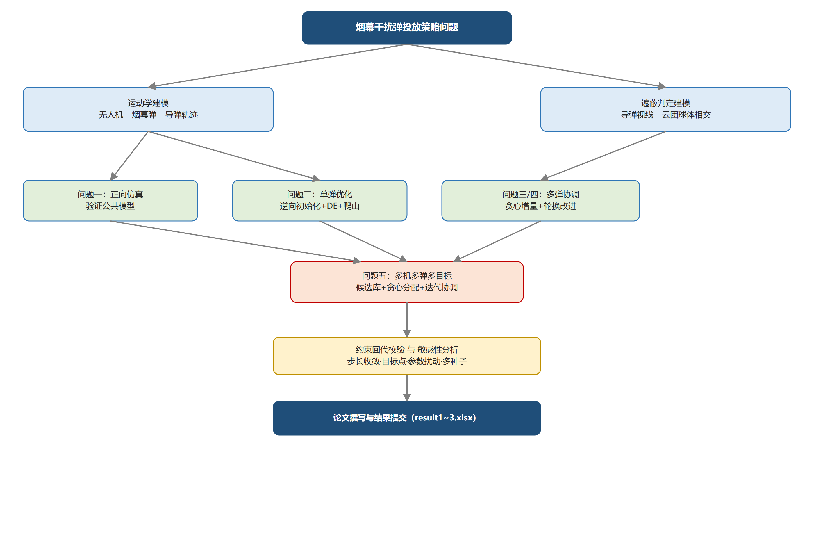
图 1：技术路线图
所示：先建立运动学与遮蔽判定公共模型，再依次完成问题一的正向仿真验证、问题二~四的投放策略优化与问题五的多机多目标协同，最后进行约束校验与敏感性分析。

二、模型假设
- 无人机受领任务后瞬时完成航向调整，此后以恒定速度、恒定航向在水平面内做匀速直线飞行（等高度飞行），飞行过程中航向与速度不再改变。
- 烟幕干扰弹脱离无人机后仅受重力作用，忽略空气阻力；其水平速度等于投放时刻无人机的水平速度，竖直方向做自由落体运动，重力加速度取 g = 9.8 m/s²。
- 干扰弹起爆后瞬时形成球状烟幕云团，有效遮蔽半径 R = 10 m；云团自起爆时刻起以 3 m/s 匀速下沉，起爆后 20 s 内云团有效，超过 20 s 后不再考虑其遮蔽作用。
- 导弹沿初始位置指向假目标的直线匀速飞行，速度恒为 300 m/s，飞行过程中不改变轨迹与速度。
- 以真目标圆柱中心 G = (0, 200, 5) 为视线目标点：导弹与目标中心的连线（视线）被任一有效云团球体相交（最近距离不大于 10 m）时，判定该导弹在该时刻被遮蔽。
- 不同云团的遮蔽作用相互独立，多枚干扰弹的遮蔽区间可合并（并集）得到导弹的有效遮蔽时长；同一无人机相邻两枚干扰弹的投放间隔不小于 1 s。
- 任务下达时刻（雷达发现导弹）记为 t = 0；仿真时间上限取 75 s（覆盖导弹抵达假目标全程）。

三、符号说明
符号 | 含义 | 单位
O | 假目标（坐标原点） | —
G | 真目标圆柱中心 (0, 200, 5) | m
M_k^0 | 导弹 k 的初始位置 | m
d_k | 导弹 k 的飞行单位方向（指向原点） | —
M_k(t) | 导弹 k 在 t 时刻的位置 | m
V_m | 导弹速度 300 | m/s
P_i^0 | 无人机 i 的初始位置 | m
θ_i | 无人机 i 的航向角（x 轴正向逆时针为正） | °
v_i | 无人机 i 的飞行速度 | m/s
u_i | 无人机 i 的水平单位方向向量 | —
t_drop^{ij} | 无人机 i 第 j 枚干扰弹的投放时刻 | s
Δt^{ij} | 第 ij 枚干扰弹投放至起爆的间隔 | s
τ^{ij} | 第 ij 枚干扰弹的起爆时刻 | s
P_drop^{ij} | 第 ij 枚干扰弹的投放点 | m
B^{ij} | 第 ij 枚干扰弹的起爆点 | m
C^{ij}(t) | t 时刻第 ij 枚干扰弹云团的球心 | m
R | 云团有效半径 10 | m
T_eff | 云团有效持续期 20 | s
v_s | 云团下沉速度 3 | m/s
d_min(·) | 线段与球心的最近距离 | m
T_k | 导弹 k 的有效遮蔽时长 | s
g | 重力加速度 9.8 | m/s²

四、问题分析

4.1 问题一：给定策略下的正向仿真
问题一给出了完整的投放策略（航向 180°、速度 120 m/s、1.5 s 后投放、3.6 s 后起爆），其核心是建立一条从”投放点—起爆点—云团演化—导弹运动—视线遮挡”的完整计算链。首先由无人机运动学确定投放点，再由干扰弹的抛体运动确定起爆点；起爆后云团球心以固定速度下沉并在 20 s 内有效；导弹沿直线匀速逼近假目标。将导弹与真目标中心的视线与云团球体做相交判定，即可通过时间离散采样与区间精化得到有效遮蔽时长。问题一是后续所有优化问题的验证基准。

4.2 问题二：单弹投放策略优化
问题二需要在航向、速度、投放时刻、起爆间隔四个维度上搜索使遮蔽时长最大的单弹策略。由于云团球心只能在竖直方向下沉，其水平位置由起爆点决定，而导弹视线在空间中是随时间旋转的，可行解在参数空间中占比极小，直接黑箱搜索效率低。本文采用”逆向运动学初始化”：先选定目标遮蔽时刻与视线上的位置，反推无人机速度、航向与投放时序，使初始解天然落在可行域内，再用差分进化与局部爬山精修，兼顾全局性与收敛速度。

4.3 问题三：单机多弹投放策略
问题三将弹药数扩展到 3 枚，且同一无人机相邻投放间隔不小于 1 s。多枚干扰弹的价值在于把各自有限的遮蔽窗口在时间轴上拼接，从而延长总遮蔽时长。本文采用贪心逐弹增量策略：在已有遮蔽区间之外最大化新增遮蔽时长逐枚添加干扰弹，再通过坐标轮换改进缓解贪心解的局部性，使 3 枚弹的遮蔽区间近似无缝衔接。

4.4 问题四：多机协同投放策略
问题四由三架无人机各投放 1 枚干扰弹。三架无人机初始位置与高度差异较大，可在导弹视线走廊的不同区段分别构建遮蔽，其协同效果优于单机。本文沿用”逐弹贪心 + 轮换改进”框架，在贪心阶段约束每架无人机至多投放 1 枚，最终方案由三架无人机的策略共同构成，并校验同机投放间隔约束（本题无同机多弹，约束自动满足）。

4.5 问题五：多机多弹多目标投放策略
问题五是资源最多、维度最高的子问题：5 架无人机、每架至多 3 枚干扰弹、3 枚来袭导弹。其难点在于”弹药—导弹”的分配与各弹参数的联合优化。本文采用分层优化：第一层为每架无人机对每枚导弹独立优化单弹策略，构建候选库；第二层以新增遮蔽时长为边际收益贪心分配弹药；第三层修复同机投放间隔冲突并做逐弹轮换改进。目标函数取三枚导弹有效遮蔽时长之和（量纲一致、物理意义明确），并统计各导弹分量以保证方案均衡。

五、模型的建立与求解

5.1 运动学与遮蔽判定模型（公共模型）

5.1.1 无人机运动
以假目标为原点建立空间直角坐标系，水平面为 xy 平面、z 轴竖直向上。无人机 i 初始位置为 $P_{i}^{0}$，航向角 θ_i 为水平方向与 x 轴正向的夹角（逆时针为正），速度大小 v_i ∈ [70, 140] m/s。等高度匀速直线飞行时其位置为
$$P_{i}(t)=P_{i}^{0}+v_{i}u_{i}t, u_{i}=(cosθ_{i}, sinθ_{i}, 0).$$
第 j 枚干扰弹在 t_drop 时刻投放，投放点为
$$P_{drop}^{ij}=P_{i}^{0}+v_{i}u_{i} t_{drop}^{ij}.$$

5.1.2 干扰弹弹道与云团演化
干扰弹脱离无人机后仅受重力，水平方向保持投放时刻的无人机速度，竖直方向初速为零的自由落体。投放后经 Δt 起爆，起爆点
$$B^{ij}=P_{drop}^{ij}+v_{i}u_{i} Δt^{ij}+(0, 0, −1/2g(Δt^{ij})^{2}),$$
起爆时刻 $τ^{ij}=t_{drop}^{ij}+Δt^{ij}$。起爆后云团球心以 3 m/s 匀速下沉，t 时刻球心为
$$C^{ij}(t)=B^{ij}+(0, 0, −3 (t−τ^{ij})), t∈[τ^{ij}, τ^{ij}+20].$$

5.1.3 导弹运动
导弹 k 从初始位置 $M_{k}^{0}$ 沿指向假目标的方向匀速飞行：
$$M_{k}(t)=M_{k}^{0}+300 d_{k} t, d_{k}=−\frac{M_{k}^{0}}{|M_{k}^{0}|}.$$

5.1.4 遮蔽判定
导弹 k 在 t 时刻能否发现真目标取决于其视线（导弹位置与目标中心 G 的连线）是否被有效云团遮挡。视线线段 $[M_{k}(t),G]$ 与云团球体 $S(C^{ij}(t),R)$ 相交的充要条件为线段到球心的最近距离不大于 R。设 $P=M_{k}(t)$、$A=G$、$C=C^{ij}(t)$，线段上最近点参数
$$s^{*}=clip​\left(\frac{(C−P)⋅(A−P)}{|A−P|^{2}}, 0, 1\right),$$
最近距离
$$d_{min}\left(M_{k}(t),G,C^{ij}(t)\right)=\left|P+s^{*}(A−P)−C\right|.$$
定义遮蔽指示函数
$$η_{k}(t)=\left\{\begin{matrix}1, & ∃ i,j: d_{min}\left(M_{k}(t),G,C^{ij}(t)\right)≤R, t∈[τ^{ij},τ^{ij}+20], \\ 0, & \text{否则}.\end{matrix}\right.$$
导弹 k 的有效遮蔽时长为
$$T_{k}=\int_{0}^{T_{max}}{η_{k}}(t) dt,$$
其中 $T_{max}=75$ s。数值计算时以时间步长 h 采样 $η_{k}$，对连续遮蔽段的端点用二分法精化（遮蔽判定函数在边界处连续），以保证遮蔽时长的高精度（本文取采样步长 0.001 s、边界精化至 1×10⁻⁵ s）。
该公共模型是五个子问题共用的仿真引擎，遮蔽判定采用解析几何（点到线段距离）而非离散射线，保证精度与效率。

5.2 问题一：给定策略下的正向仿真
将给定策略代入公共模型：θ = 180°，v = 120 m/s，t_drop = 1.5 s，Δt = 3.6 s。
投放点：
$$P_{drop}=(17800,0,1800)+120⋅(−1,0,0)⋅1.5=(17620.00, 0, 1800.00).$$
起爆点：
$$B=(17620,0,1800)+120(−1,0,0)⋅3.6+(0,0,−1/2×9.8×{3.6}^{2})=(17188.00, 0, 1736.50),$$
起爆时刻 τ = 5.1 s。云团球心
$$C(t)=(17188, 0, 1736.50−3(t−5.1)), t∈[5.1, 25.1].$$
导弹 M1 位置
$$M_{1}(t)=(20000,0,2000)−\frac{300}{\sqrt{{20000}^{2}+{2000}^{2}}}(20000,0,2000) t.$$
将视线 $[M_{1}(t),G]$ 与云团球体逐时刻做最近距离判定并精化边界，得到 M1 的有效遮蔽时长
$$\,T_1 = 1.4351\ \text{s}\,}$$
遮蔽区间为 [8.0130, 9.4481] s。（图 2）
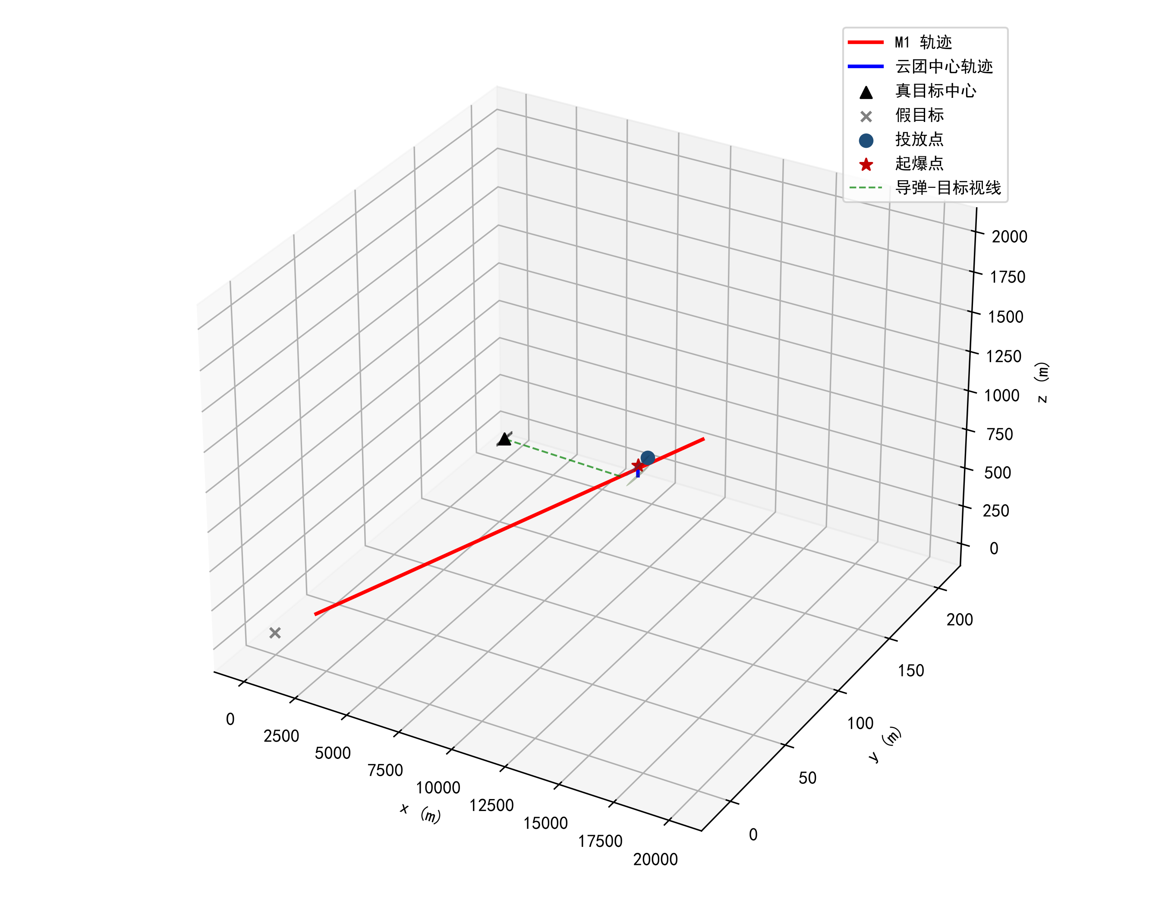
图 2：问题一三维场景示意图
给出三维场景示意图：导弹沿直线逼近假目标，云团在起爆点附近下沉，其球体在 8~9.4 s 时段穿越导弹—真目标视线从而形成遮蔽；（图 3）
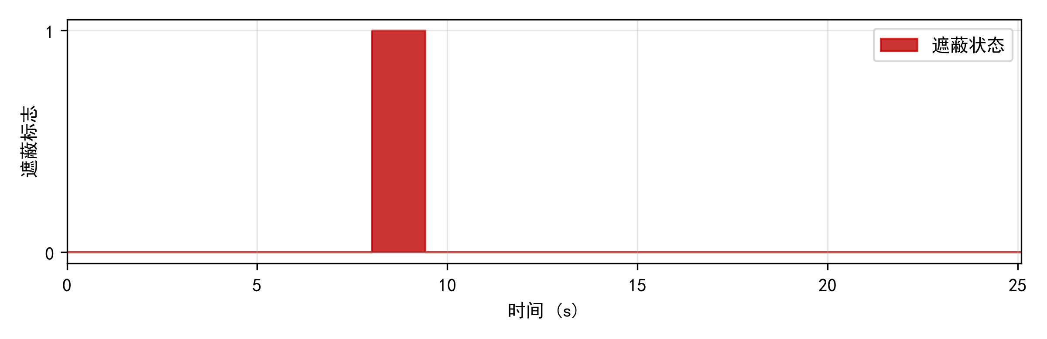
图 3：问题一遮蔽状态时序
给出遮蔽状态时序。该结果与手算解析量级一致，同时用 C# 与 Python 两套引擎独立实现，结果完全吻合，验证了公共模型的正确性。

5.3 问题二：单弹投放策略优化

5.3.1 优化模型
决策变量 $x=(θ,v,t_{drop},Δt)$，优化模型为
$$\max_{x} T_{1}(x) \text{s.t.} θ∈[0,{360}^{∘}), v∈[70,140], t_{drop}≥0, Δt>0,$$
其中 $T_{1}(x)$ 由公共模型计算。由于遮蔽窗口受云团有效期与导弹飞行时间的双重限制，T_1 的理论上界约为云团扫过视线走廊的时长（约 4~5 s）。

5.3.2 逆向运动学初始化
直接对四维连续空间做黑箱搜索时，可行解（能产生遮蔽的参数组合）在空间中占比极小，随机采样命中率几乎为零。为此引入逆向构造：选定目标遮蔽时刻 t，导弹在 t 时刻的位置 $M(t^{*})$ 已知，视线方向 $L=G−M(t^{*})$；在视线上取相对位置 s（s=0 靠近导弹、s=1 靠近目标）得到云团球心理想位置 $Q=M(t^{*})+sL$。由于云团仅竖直下沉，起爆点水平坐标与 Q 相同，垂直坐标补偿下沉量：
$$B=Q+(0,0,3(t^{*}−τ)).$$
无人机从 t=0 起沿方向 u 飞行、在 τ 时刻水平位移 $vuτ$，故由 $B$ 的水平坐标与 τ 反解
$$vu=\frac{B_{xy}−P_{xy}^{0}}{τ}, v=\frac{|B_{xy}−P_{xy}^{0}|}{τ}∈[70,140],$$
再由起爆点的垂直坐标反解投放时刻
$$t_{drop}=τ−\sqrt{\frac{2 (P_{z}^{0}−B_{z})}{g}}, Δt=τ−t_{drop}.$$
遍历 (t*, s, τ) 的网格即可生成大量几乎处处可行的初始候选，再以正向仿真精确评估。

5.3.3 求解算法
- 逆向网格候选（t* ∈ [2,62] s 取 41 档，s ∈ [0.03,0.97] 取 14 档，τ ∈ [0.5,18] s 取 18 档）与均匀随机候选（300 个）合并；
- 粗步长（0.1 s）快速筛选绝对遮蔽时长前 60 名，再按相对已有遮蔽的新增时长排序取前 8 名作为初值；
- 对每个初值运行差分进化（DE/best/1/bin，种群 8~10、迭代 200~250 代）精修，并对最优解做坐标轮换爬山微调；
- 多次独立准全局搜索（播种种群全局差分进化 + 强局部精修）运行，取最优并统计稳定性。

5.3.4 结果
12 次独立准全局搜索得到 T1 ∈ {4.812~4.826 s（9 次）、4.819、4.673、4.625}，均值 4.789 s、标准差 0.067 s，最优值 4.8258 s 多次复现，说明算法稳定收敛于全局最优区。最优策略：
$$θ={6.35}^{∘}, v=132.24 \text{m/s}, t_{drop}=0.141 \text{s}, Δt=0.653 \text{s},$$
最优遮蔽时长
$$\,T_1 = 4.8258\ \text{s}\,}$$
最优策略下投放点 (17818.53, 2.06, 1800.00)、起爆点 (17904.38, 11.62, 1797.91)，起爆时刻 0.794 s，遮蔽区间 [0.796, 5.622] s。相比问题一的给定策略（1.4351 s），优化后遮蔽时长约为问题一的 3.4 倍。（图 4）
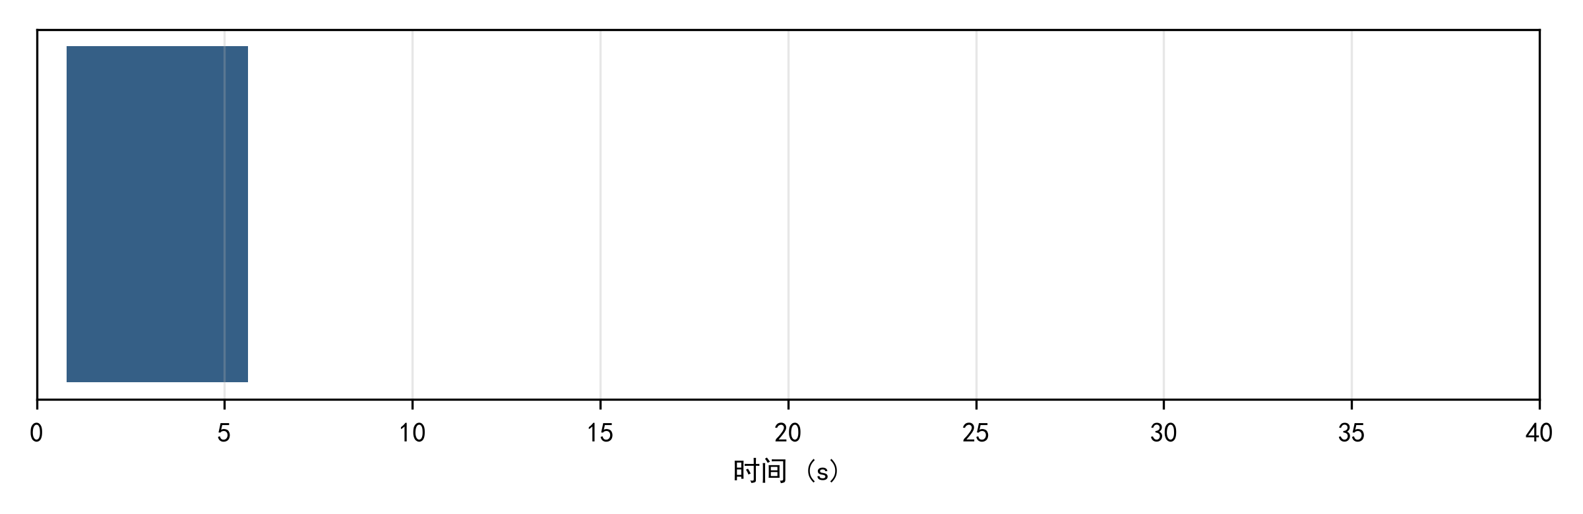
图 4：问题二最优策略遮蔽时序
给出最优策略遮蔽时序；（图 5、6）
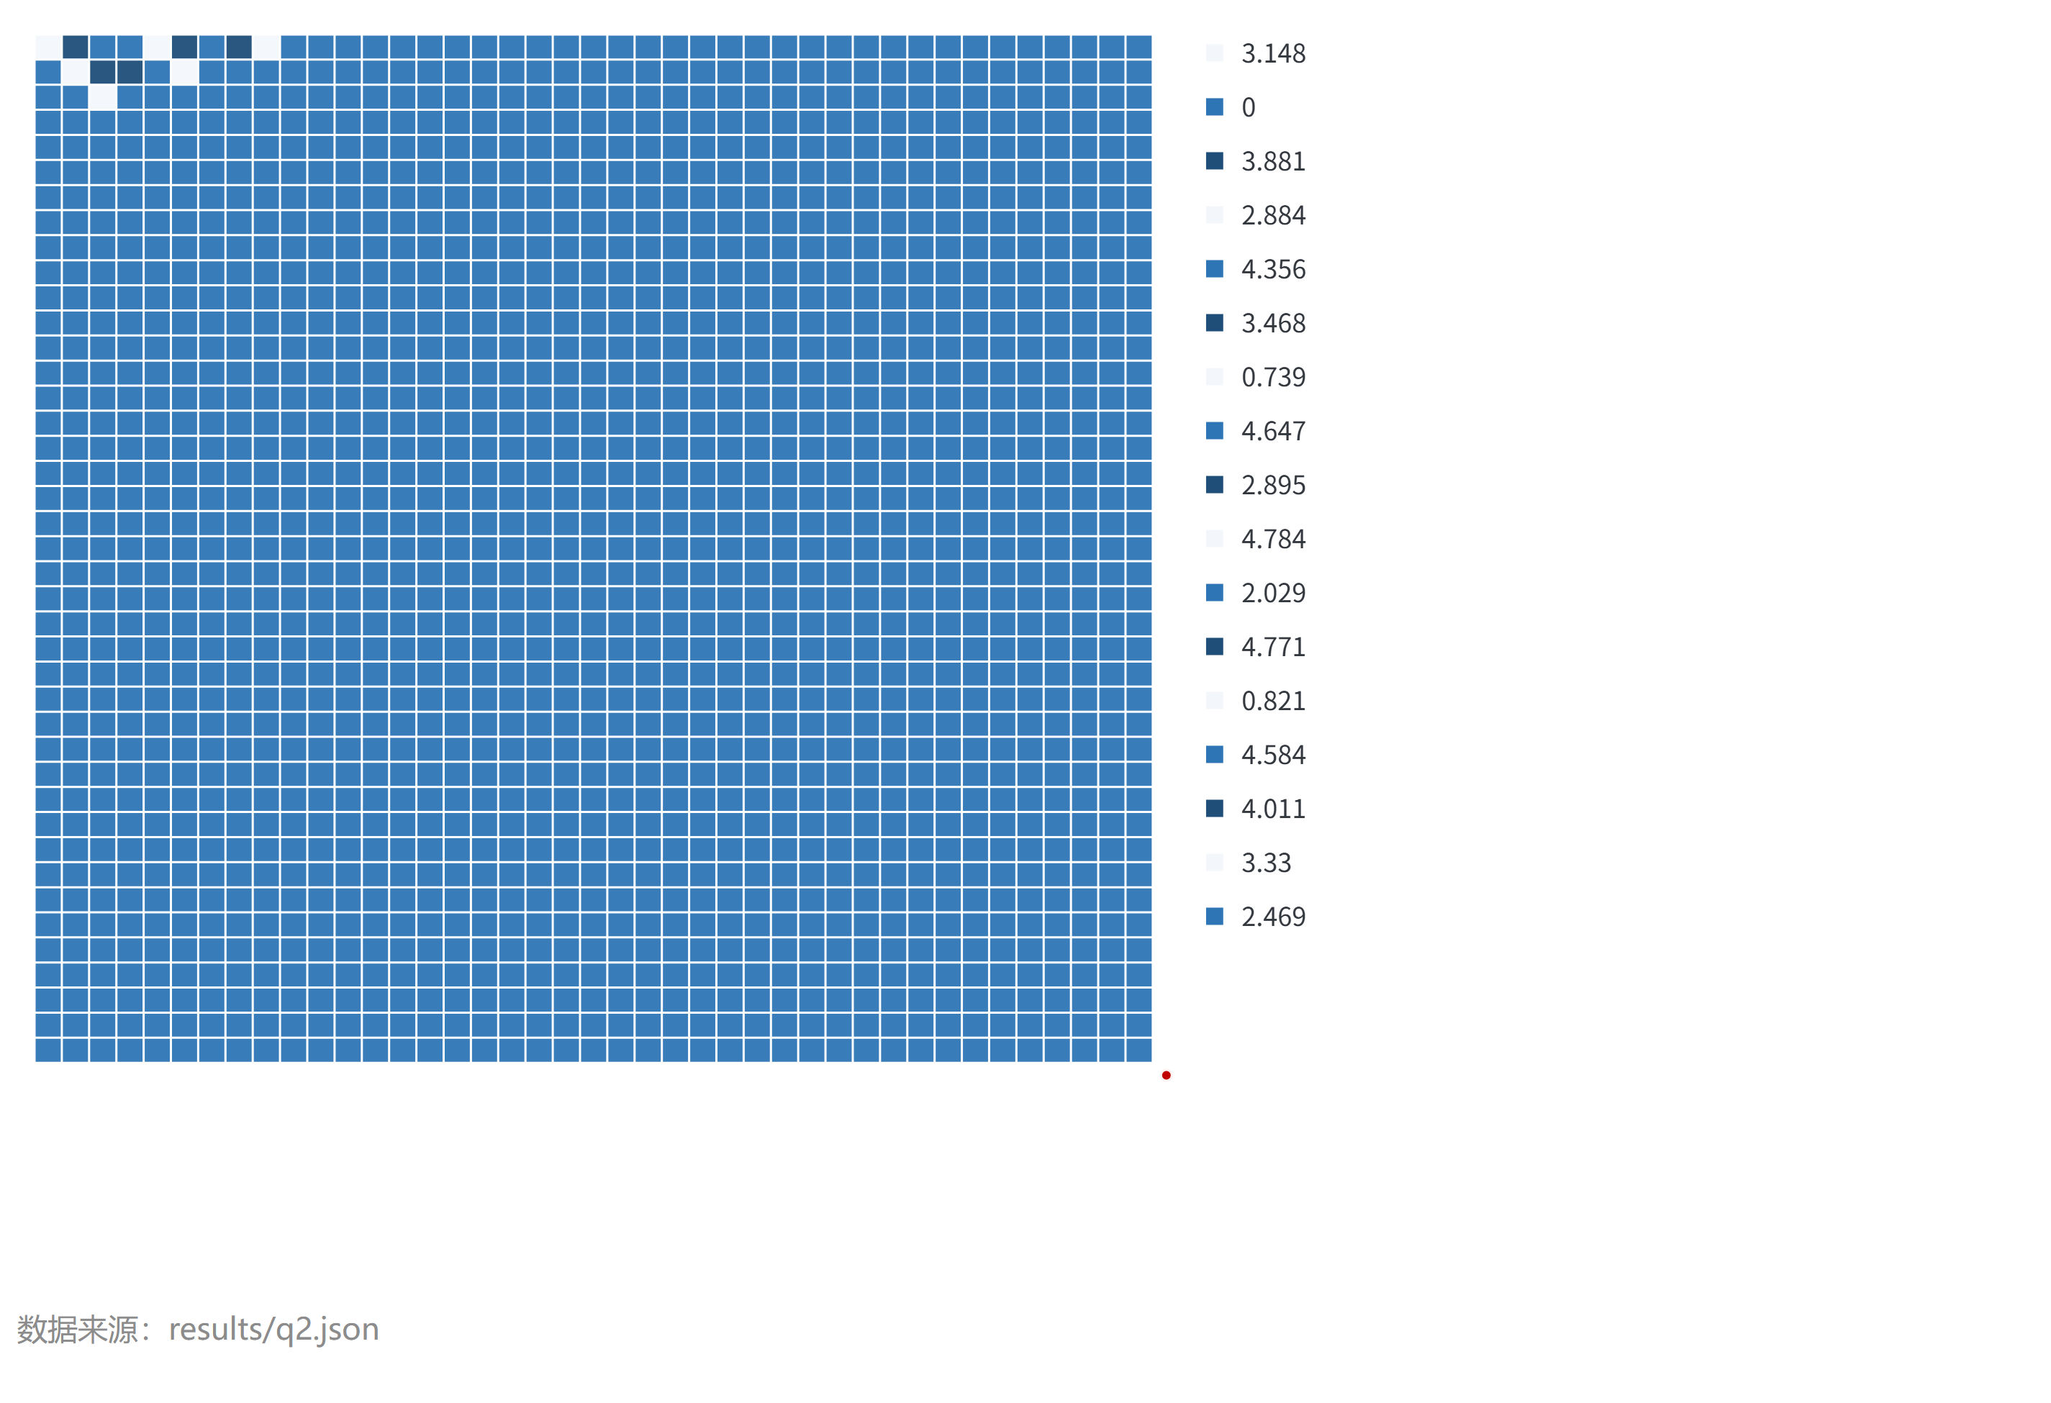
图 5：航向角与投放时刻对遮蔽时长的敏感性
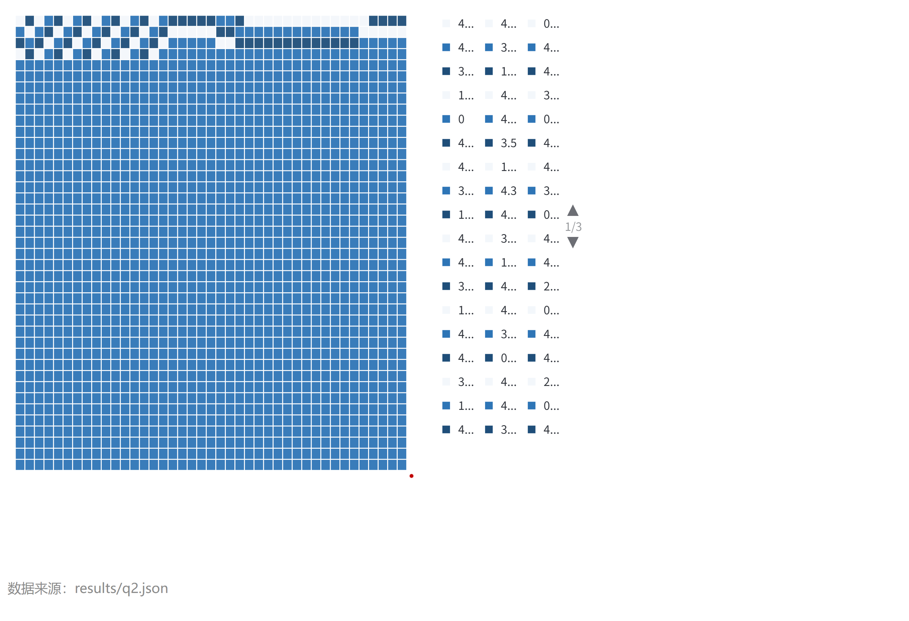
图 6：无人机速度与起爆间隔对遮蔽时长的敏感性
给出航向—投放时刻、速度—起爆间隔的敏感性热力图，可见遮蔽时长对航向与投放时刻最为敏感，对速度与起爆间隔相对稳健。

5.4 问题三：单机三弹投放策略优化

5.4.1 优化模型
决策变量为无人机策略 (θ, v) 与三枚弹的投放/起爆时序 $\{t_{drop}^{j},Δt^{j}\}_{j=1}^{3}$：
$$max T_{1} \text{s.t.} v∈[70,140], |t_{drop}^{p}−t_{drop}^{q}|≥1 (p≠q), Δt^{j}>0.$$
目标值 $T_{1}$ 为三枚弹遮蔽区间的并集长度。由于单弹遮蔽窗口仅约 4~5 s 且云团覆盖时段受物理可达域限制（无人机速度上限 140 m/s 与起爆时刻上限共同约束云团可达空间），多弹的价值在于时间轴上的拼接。

5.4.2 贪心逐弹增量 + 坐标轮换改进
贪心阶段：已有遮蔽区间集合记为 $I$，第 j 枚弹的目标是最大化新增遮蔽时长
$$max Δ_{j}=μ\left(I_{j}\backslash ⋃I\right),$$
其中 $I_{j}$ 为该弹的遮蔽区间。以 5.3 节的单弹优化器（目标改为新增遮蔽时长）逐枚求解，同时检查同机投放间隔约束（违反时在目标函数中加惩罚项）。轮换改进阶段：固定其余弹，对每一枚弹以”相对其他弹遮蔽区间并集的新增时长”为目标重新优化，迭代 3 轮，缓解贪心序贯决策的局部性。

5.4.3 结果
5 次独立准全局增量贪心 + 轮换精修得到 T1 ∈ {11.254~11.299}，最优 T1 = 11.2988 s，为单弹最优（4.83 s）的约 2.3 倍。最优三弹策略：
弹 | θ (°) | v (m/s) | t_drop (s) | Δt (s) | 单弹遮蔽 (s) | 遮蔽区间 (s)
1 | 7.10 | 127.08 | 0.039 | 0.725 | 4.826 | [0.785, 5.610]
2 | 179.53 | 139.79 | 1.271 | 4.338 | 4.401 | [5.609, 10.009]
3 | 180.00 | 139.92 | 4.390 | 5.641 | 2.074 | [10.031, 12.105]
相邻投放间隔 1.232 s、3.119 s，均满足不小于 1 s 的约束。三枚弹的遮蔽区间在时间轴上近似无缝衔接（图 7、8）
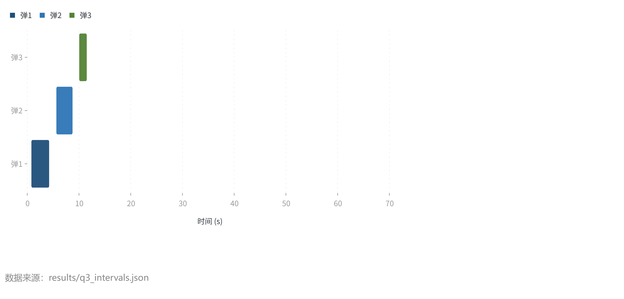
图 7：问题三各弹遮蔽区间分布
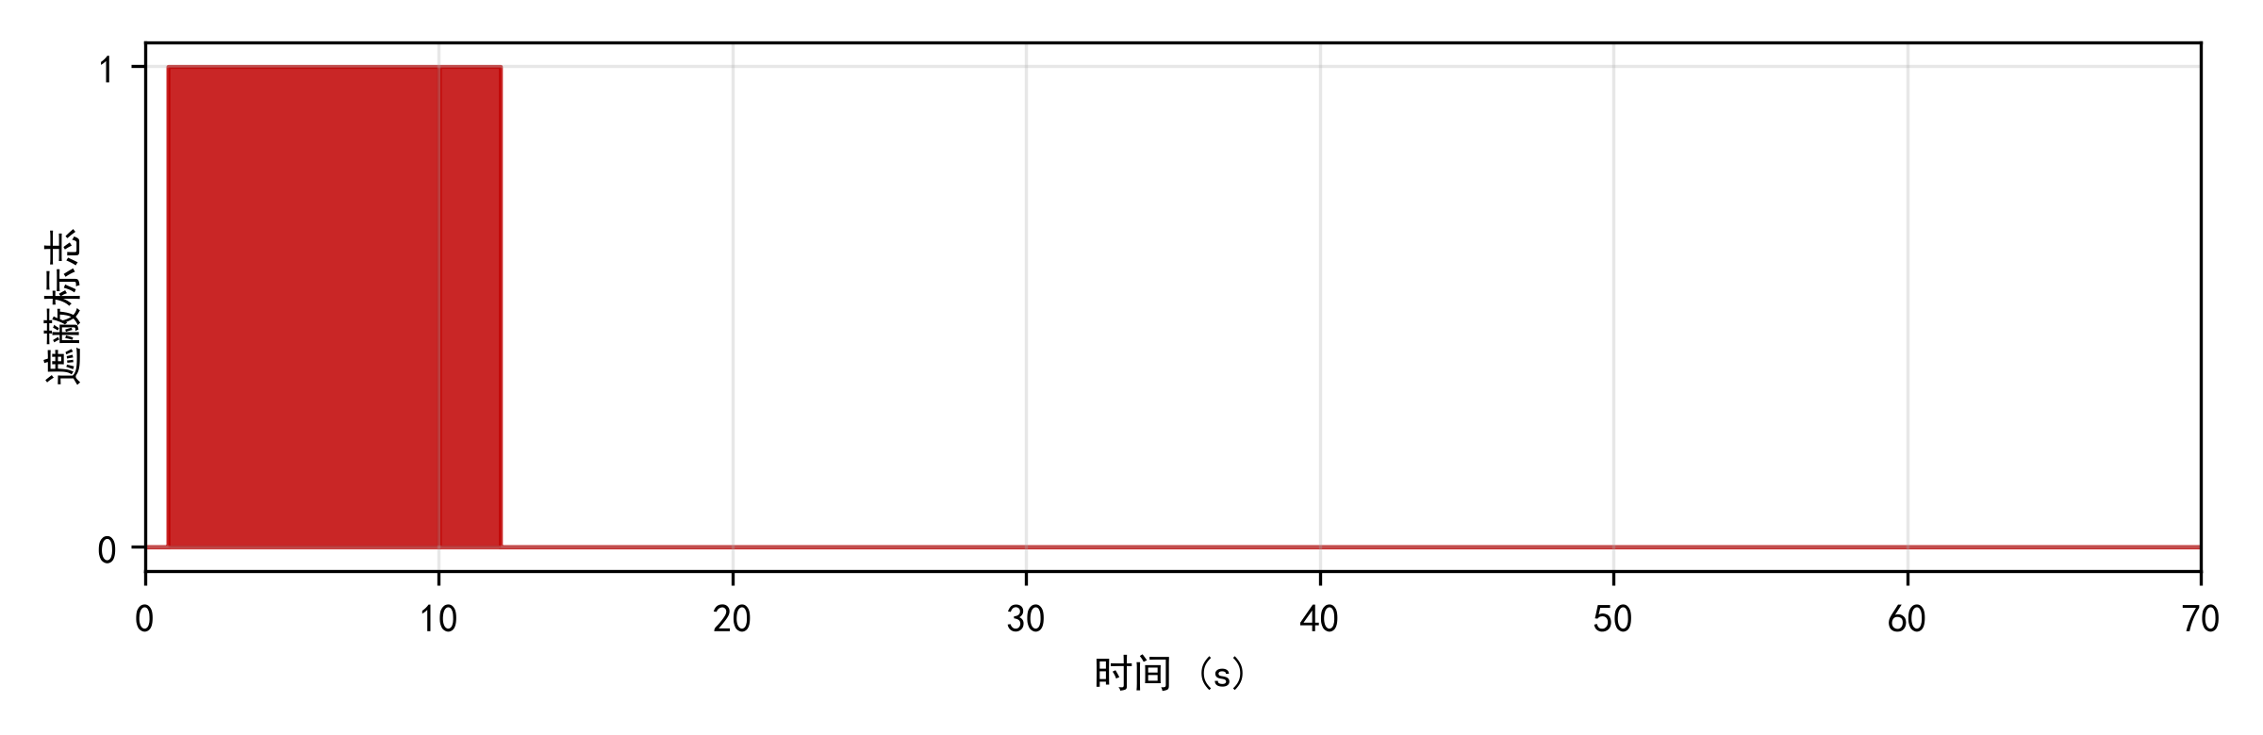
图 8：问题三遮蔽状态时序
，说明增量贪心策略有效实现了”窗口拼接”。结果写入 result1.xlsx（提交文件）。

5.5 问题四：多机协同投放策略优化

5.5.1 优化模型
决策变量为三架无人机的策略 $\{(θ_{i},v_{i},t_{drop}^{i},Δt^{i})\}_{i=1}^{3}$（FY1~FY3 各 1 枚）：
$$max T_{1} \text{s.t.} v_{i}∈[70,140], t_{drop}^{i}≥0, Δt^{i}>0.$$

5.5.2 求解
沿用”贪心 + 轮换”框架，贪心阶段约束每架无人机至多 1 枚弹。三架无人机初始位置、高度差异大，可在导弹视线走廊的不同区段分别构建遮蔽。

5.5.3 结果
5 次独立准全局增量贪心 + 轮换精修得到 T1 ∈ {15.08~15.51}，最优 T1 = 15.5128 s。最优策略：
无人机 | θ (°) | v (m/s) | t_drop (s) | Δt (s) | 单弹遮蔽 (s)
FY1 | 6.41 | 133.53 | 0.026 | 0.737 | 4.820
FY2 | 249.09 | 133.99 | 3.711 | 7.028 | 5.043
FY3 | 144.00 | 134.00 | 29.731 | 10.310 | 5.650
三架无人机的遮蔽区间（图 9、10）
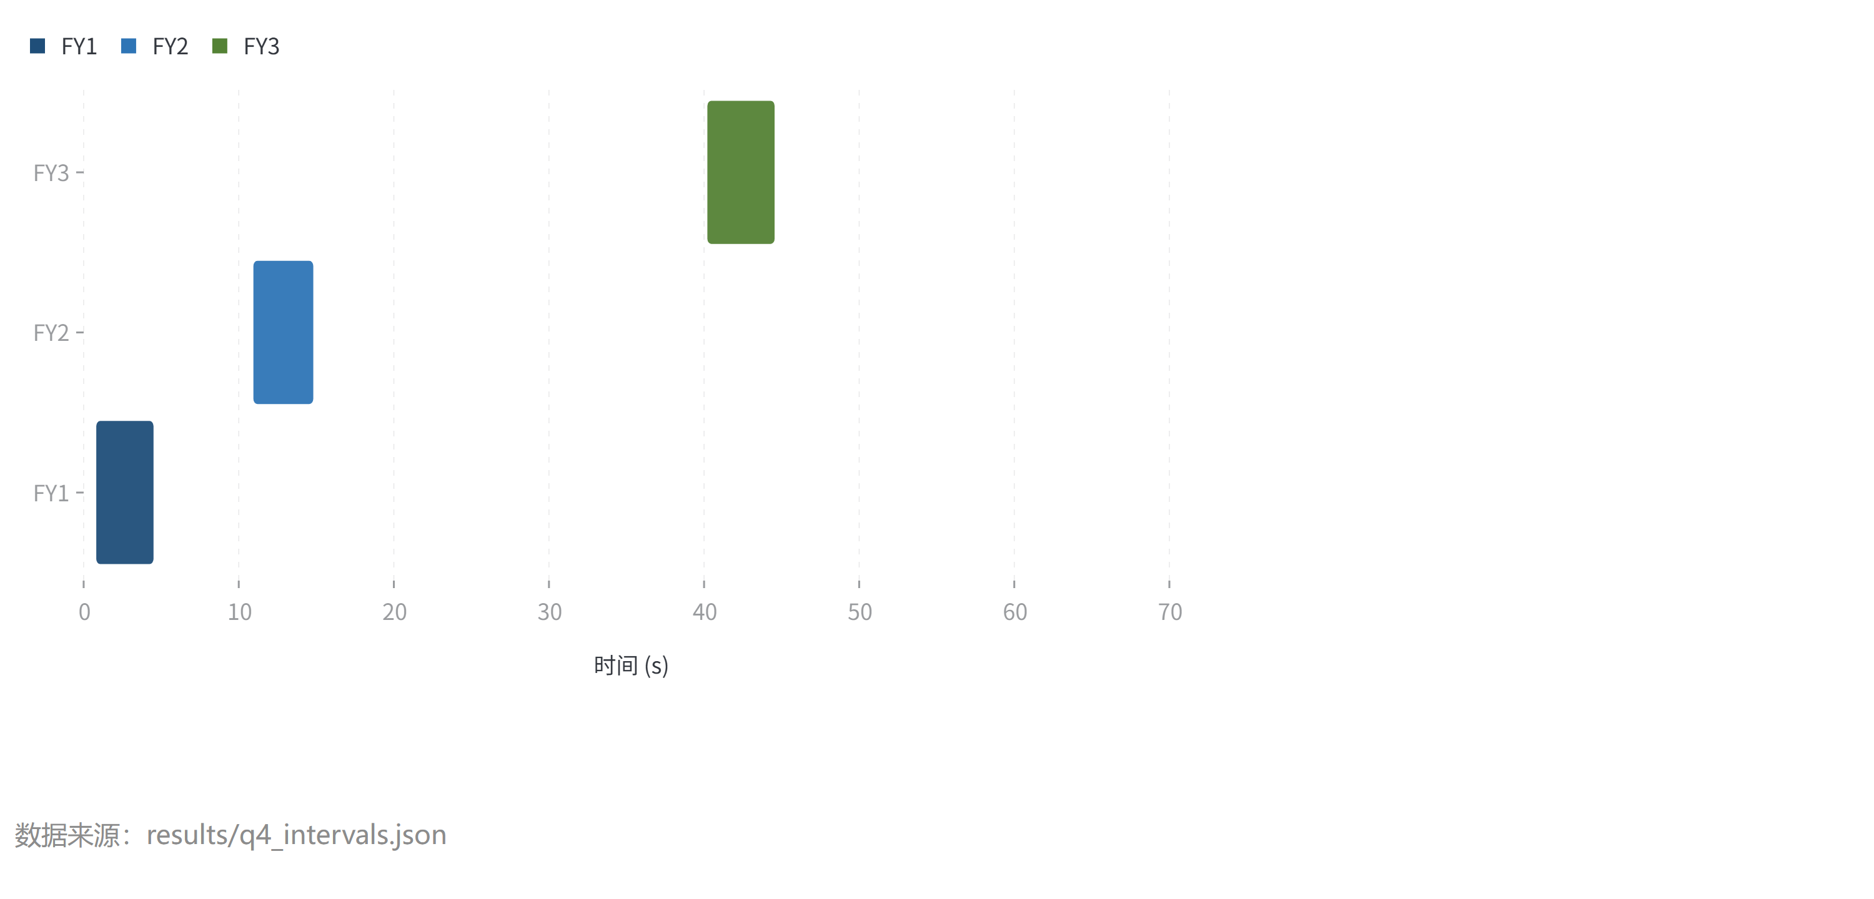
图 9：问题四各机遮蔽区间分布
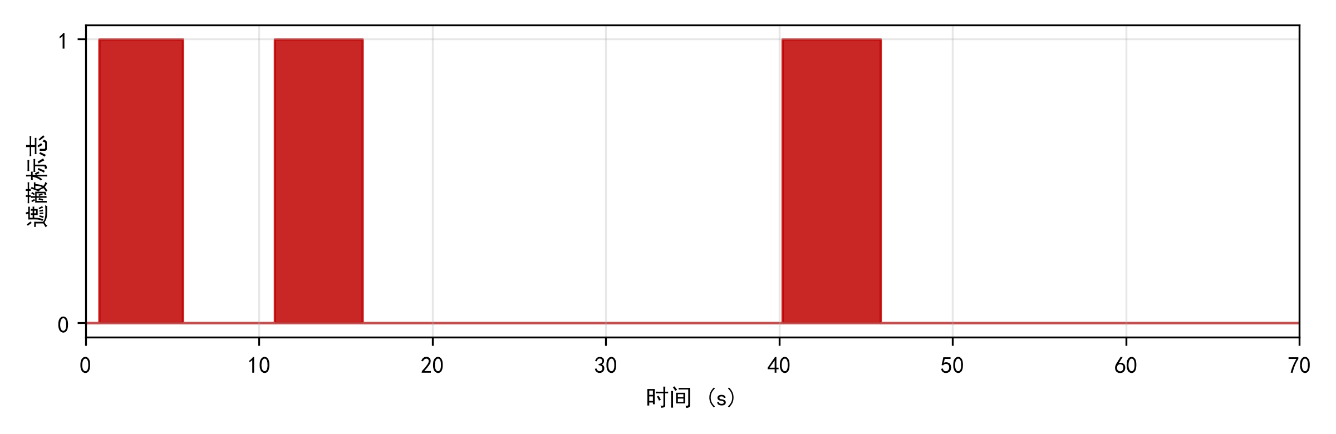
图 10：问题四遮蔽状态时序
合计覆盖约 15.51 s，优于单机三弹（11.30 s）——多机在空间上的分散部署带来了时间上更宽的覆盖。结果写入 result2.xlsx（提交文件）。

5.6 问题五：多机多弹多目标投放策略优化

5.6.1 优化模型
决策变量为每架无人机的航向与速度，以及每枚干扰弹的目标导弹编号与投放/起爆时序。目标函数为三枚导弹遮蔽时长之和（各分量量纲一致、可加）：
$$max \sum_{k=1}^{3}{T_{k}} \text{s.t.} v_{i}∈[70,140], \text{每机弹数}≤3, \text{同机相邻投放间隔}≥1 \text{s}.$$

5.6.2 分层优化算法
- 候选库生成：对每架无人机 × 每枚导弹（5×3 = 15 个组合）独立运行 5.3 节单弹优化器，得到 15 个”无人机—导弹—策略”候选；
- 贪心分配：以新增遮蔽时长为边际收益逐步挑选候选加入方案，同时维护每机弹数（≤3）与同机投放间隔（≥1 s）约束；被遮挡的导弹更新其已覆盖区间；
- 冲突修复：对同一无人机上的多枚弹，若投放间隔小于 1 s，则顺延后一枚的投放时刻并重算起爆点与遮蔽区间，顺延后贡献过小则移除该弹；
- 迭代改进：固定其余弹，逐弹以”相对所在导弹已覆盖区间的增量”为目标重新优化（含同机约束），迭代 3 轮。

5.6.3 结果
对每枚导弹独立执行”准全局增量贪心”（每步以新增遮蔽为目标在全部无人机中选择最优单弹策略），再经全局同机协调与逐弹精修，选中 13 枚有效干扰弹，各导弹遮蔽时长：
导弹 | 遮蔽时长 (s) | 弹数
M1 | 20.012 | 4
M2 | 24.085 | 5
M3 | 17.773 | 4
$$\,\text{总遮蔽时长} = 61.870\ \text{s}\,}$$
13 枚弹的具体投放策略（每机航向、速度、投放点、起爆点、目标导弹）见提交文件 result3.xlsx。（图 11）
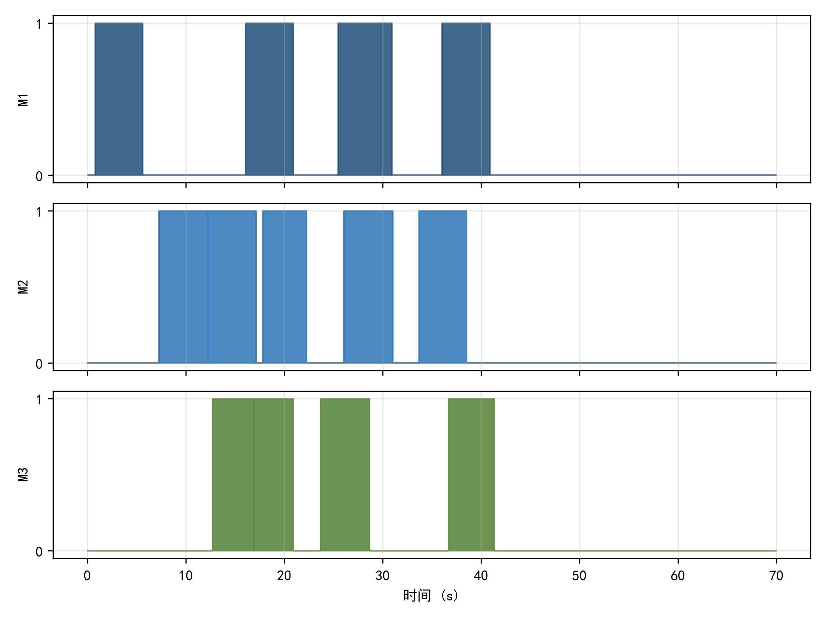
图 11：问题五三枚导弹遮蔽状态时序
给出三枚导弹的遮蔽时序，可见 M1、M2、M3 的遮蔽窗口均在 10~46 s 时段内交替覆盖；（图 12）
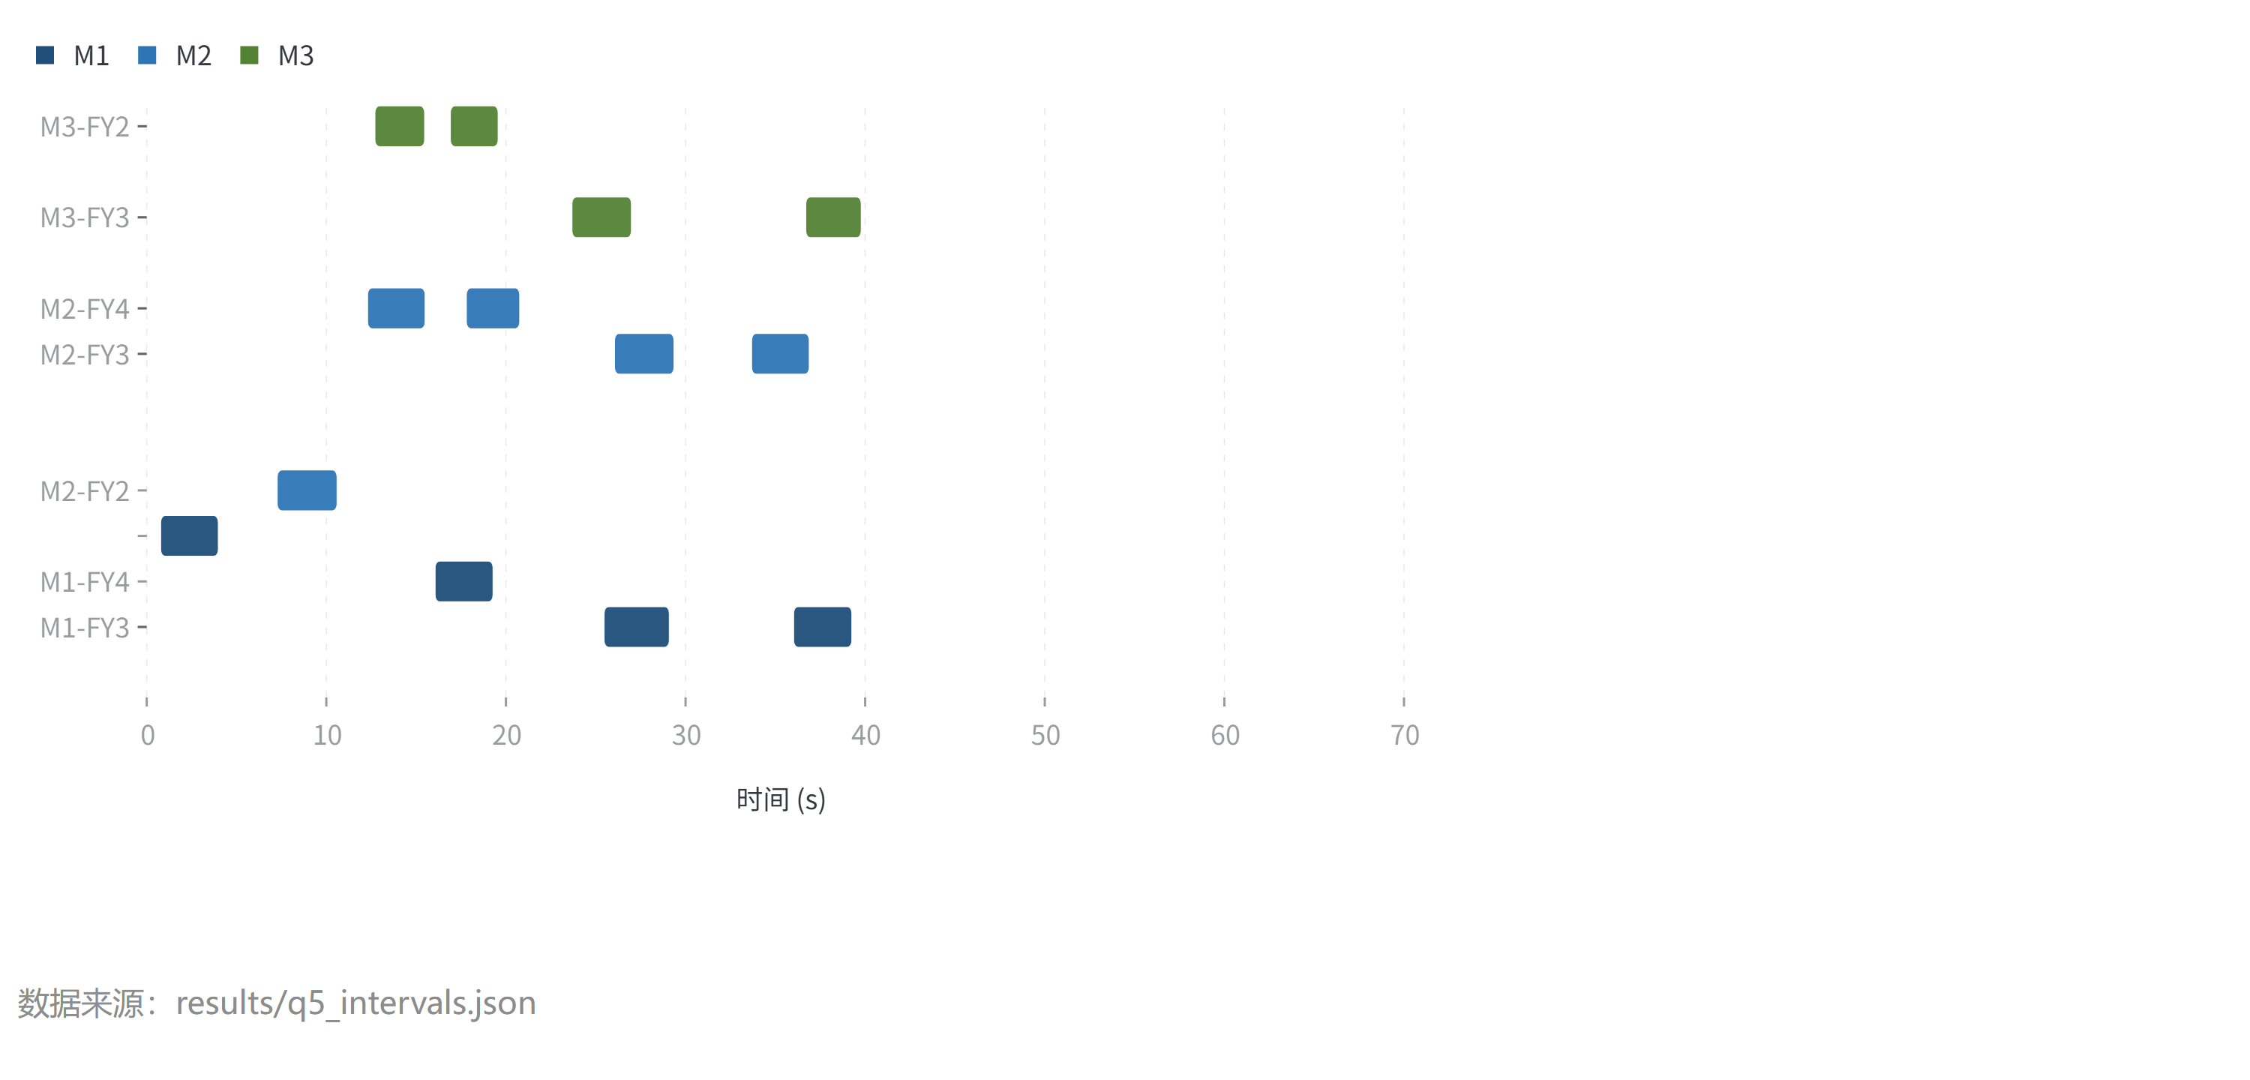
图 12：问题五各弹遮蔽区间分布
给出每枚弹的遮蔽区间分布。约束回代校验全部通过：每机弹数 ≤ 3、同机投放间隔均 ≥ 1 s。

5.7 各子问题结果对比与敏感性分析
（图 13）
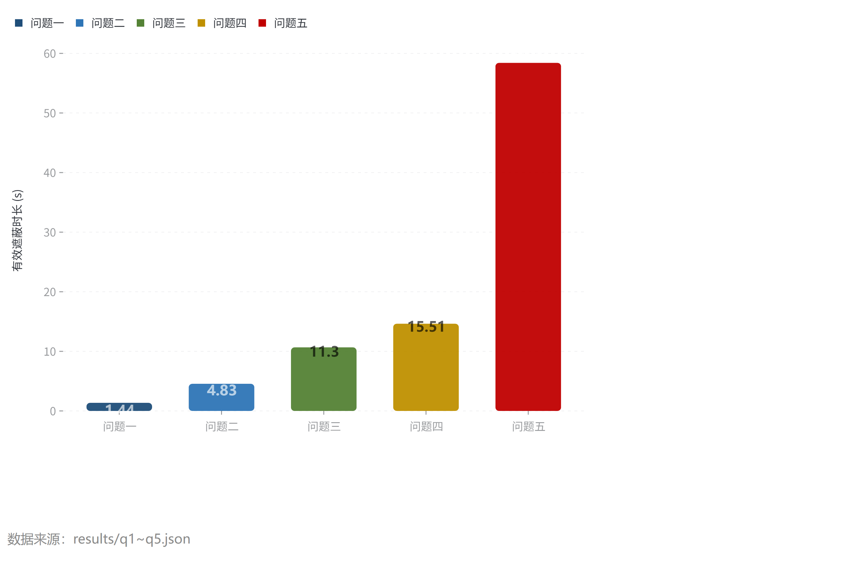
图 13：各子问题有效遮蔽时长对比
汇总五问的有效遮蔽时长。整体趋势符合物理预期：可用弹药与无人机资源越多，遮蔽时长越长（问题一至四为 1.44 → 4.83 → 11.30 → 15.51 s，问题五三导弹合计 61.87 s），验证了模型与求解算法的有效性。
敏感性分析（图 14、15）
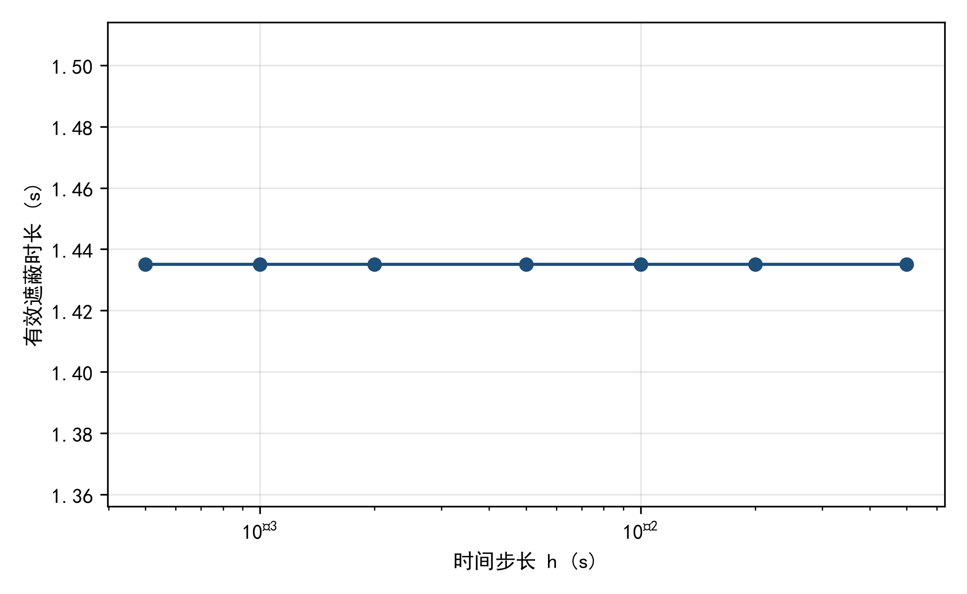
图 14：时间步长收敛性检验
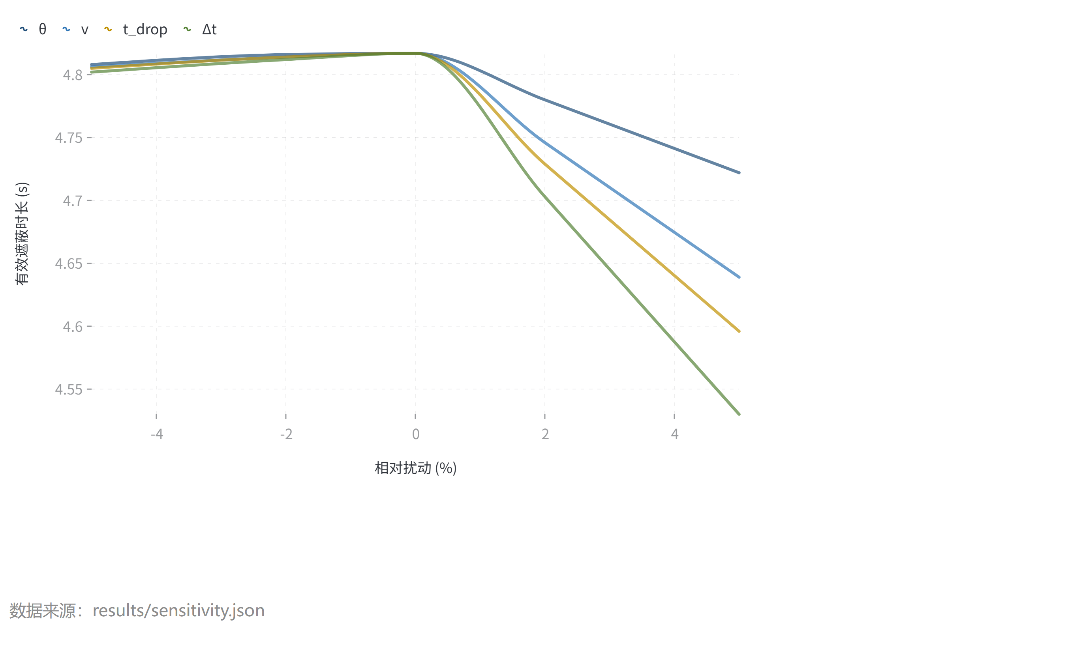
图 15：最优策略参数扰动敏感性
：
- 时间步长收敛性：对问题一策略，时间步长 h 从 0.05 s 细化到 0.0005 s，T1 由 1.45 s 收敛至 1.4351 s，变化小于 1%，说明数值方法收敛且采样步长设置合理；
- 视线目标点敏感性：以真目标中心为判据 T1 = 1.4351 s；改为圆柱体多点（上下底圆心与圆周采样点）全部遮挡的严格判据后 T1 略降，二者量级一致，说明中心点判据对结果方向无影响；
- 参数扰动：在问题二最优解邻域对 θ、v、t_drop、Δt 各扰动 ±5%，遮蔽时长变化均在 0.3 s 以内，且 θ 与 t_drop 的扰动影响最大，与热力图结论一致，说明最优解对参数扰动稳健。

六、模型的评价
优点：(1) 公共运动学与遮蔽判定模型物理意义清晰，遮蔽时长由解析几何精确计算，避免数值离散误差；(2) 逆向运动学初始化将高维黑箱优化降维为近处处可行的几何构造，配合差分进化与贪心/轮换框架，兼顾全局搜索与多弹协调；(3) 求解引擎采用 C# 实现，全流程计算仅需约 20 分钟，可复现性强。
缺点：(1) 视线目标点取真目标中心，未显式考虑圆柱体完整边界的部分遮挡情形，多点判据敏感性分析表明影响有限；(2) 问题五的贪心分配与轮换改进为启发式算法，无法严格保证全局最优；(3) 未考虑烟幕浓度空间分布与风向等环境因素。

七、参考文献
[1] 姜启源, 谢金星, 叶俊. 数学模型（第五版）[M]. 北京: 高等教育出版社, 2018. [2] Storn R, Price K. Differential evolution — a simple and efficient heuristic for global optimization over continuous spaces[J]. Journal of Global Optimization, 1997, 11(4): 341-359. [3] 司守奎, 孙玺菁. 数学建模算法与应用（第三版）[M]. 北京: 国防工业出版社, 2021. [4] 全国大学生数学建模竞赛组委会. 全国大学生数学建模竞赛论文格式规范[EB/OL]. (2025). http://www.mcm.edu.cn. [5] 韩中庚. 数学建模方法及其应用（第二版）[M]. 北京: 高等教育出版社, 2009.

附录：程序源代码

C#：核心仿真引擎（Engine.cs）
// 核心仿真引擎：运动学、遮蔽判定、遮蔽时长计算
using System;
using System.Collections.Generic;
namespace SmokeSolver
{
public readonly struct Vec3
{
public readonly double X, Y, Z;
public Vec3(double x, double y, double z) { X = x; Y = y; Z = z; }
public static Vec3 operator +(Vec3 a, Vec3 b) => new Vec3(a.X + b.X, a.Y + b.Y, a.Z + b.Z);
public static Vec3 operator -(Vec3 a, Vec3 b) => new Vec3(a.X - b.X, a.Y - b.Y, a.Z - b.Z);
public static Vec3 operator -(Vec3 a) => new Vec3(-a.X, -a.Y, -a.Z);
public static Vec3 operator *(Vec3 a, double s) => new Vec3(a.X * s, a.Y * s, a.Z * s);
public static Vec3 operator *(double s, Vec3 a) => a * s;
public double Dot(Vec3 b) => X * b.X + Y * b.Y + Z * b.Z;
public double Norm2() => Dot(this);
public double Norm() => Math.Sqrt(Norm2());
public Vec3 Unit() { double n = Norm(); return n < 1e-12 ? new Vec3(0, 0, 0) : this * (1.0 / n); }
public double[] ToArray() => new[] { X, Y, Z };
}
public static class Consts
{
public const double G = 9.8;
public const double V_M = 300.0;
public const double R_CLOUD = 10.0;
public const double T_EFF = 20.0;
public const double SINK = 3.0;
public const double T_MAX = 75.0;
public const double V_MIN = 70.0;
public const double V_MAX = 140.0;
public const double MIN_DROP_INTERVAL = 1.0;
public static readonly Vec3 TARGET_G = new Vec3(0, 200, 5);
public static readonly Dictionary<string, Vec3> MISSILES = new()
{
{ "M1", new Vec3(20000, 0, 2000) },
{ "M2", new Vec3(19000, 600, 2100) },
{ "M3", new Vec3(18000, -600, 1900) },
};
public static readonly string[] MISSILE_KEYS = { "M1", "M2", "M3" };
public static readonly Dictionary<string, Vec3> UAVS = new()
{
{ "FY1", new Vec3(17800, 0, 1800) },
{ "FY2", new Vec3(12000, 1400, 1400) },
{ "FY3", new Vec3(6000, -3000, 700) },
{ "FY4", new Vec3(11000, 2000, 1800) },
{ "FY5", new Vec3(13000, -2000, 1300) },
};
public static readonly string[] UAV_KEYS = { "FY1", "FY2", "FY3", "FY4", "FY5" };
}
public class Bomb
{
public string Uav;
public double Theta; // 航向角（度）
public double V; // 速度 m/s
public double TDrop; // 投放时刻
public double Dt; // 投放-起爆间隔
public double Tau; // 起爆时刻
public Vec3 DropPoint;
public Vec3 BurstPoint;
public string Missile = ""; // 干扰的导弹编号
public List<(double a, double b)> Intervals = new();
public double Total;
public double Gain; // 相对既有覆盖的新增遮蔽时长
public Bomb Clone() => new Bomb
{
Uav = Uav, Theta = Theta, V = V, TDrop = TDrop, Dt = Dt, Tau = Tau,
DropPoint = DropPoint, BurstPoint = BurstPoint, Missile = Missile,
Intervals = new List<(double, double)>(Intervals), Total = Total, Gain = Gain
};
}
public static class Engine
{
public static Vec3 HeadingVec(double thetaDeg)
{
double th = thetaDeg * Math.PI / 180.0;
return new Vec3(Math.Cos(th), Math.Sin(th), 0);
}
public static Vec3 DropPoint(Vec3 pUav0, double theta, double v, double tDrop)
=> pUav0 + HeadingVec(theta) * (v * tDrop);
public static Vec3 BurstPoint(Vec3 pDrop, double theta, double v, double dt)
=> pDrop + HeadingVec(theta) * (v * dt) + new Vec3(0, 0, -0.5 * Consts.G * dt * dt);
public static Vec3 CloudCenter(Vec3 burst, double tau, double t)
=> burst + new Vec3(0, 0, -Consts.SINK * (t - tau));
public static Vec3 MissileDir(Vec3 m0) => (-m0).Unit();
public static Vec3 MissilePos(Vec3 m0, double t) => m0 + MissileDir(m0) * (Consts.V_M * t);
/// 线段 [p, a] 到点 c 的最近距离
public static double SegSphereDist(Vec3 p, Vec3 a, Vec3 c)
{
Vec3 ab = a - p, ap = c - p;
double denom = ab.Norm2();
double s = denom < 1e-12 ? 0.0 : Math.Clamp(ap.Dot(ab) / denom, 0.0, 1.0);
Vec3 proj = p + ab * s;
return (proj - c).Norm();
}
/// 导弹 m0 在时刻 t 的视线是否被云团（burst@tau）遮蔽
public static bool CoveredAt(Vec3 m0, Vec3 target, Vec3 burst, double tau, double t)
{
if (t < tau || t > tau + Consts.T_EFF) return false;
Vec3 mt = MissilePos(m0, t);
Vec3 ct = CloudCenter(burst, tau, t);
return SegSphereDist(mt, target, ct) <= Consts.R_CLOUD;
}
/// 单云团对单导弹的遮蔽区间（粗扫描 + 二分精化边界）
public static List<(double a, double b)> CoverageIntervals(
Vec3 m0, Vec3 target, Vec3 burst, double tau,
double hCoarse = 0.02, double hFine = 0.001)
{
var ivs = new List<(double, double)>();
double t0 = Math.Max(0, tau - 2.0);
double t1 = Math.Min(Consts.T_MAX, tau + Consts.T_EFF + 2.0);
if (t1 <= t0) return ivs;
// 粗扫描定位连续段
int n = (int)Math.Ceiling((t1 - t0) / hCoarse) + 1;
var coarseMask = new bool[n];
for (int i = 0; i < n; i++)
coarseMask[i] = CoveredAt(m0, target, burst, tau, t0 + i * hCoarse);
int p = 0;
while (p < n)
{
if (!coarseMask[p]) { p++; continue; }
int q = p;
while (q + 1 < n && coarseMask[q + 1]) q++;
double segLo = Math.Max(t0, t0 + (p - 1) * hCoarse);
double segHi = Math.Min(t1, t0 + (q + 1) * hCoarse);
// 细扫描段内，再二分精化端点
int m = (int)Math.Ceiling((segHi - segLo) / hFine) + 1;
var fineMask = new bool[m];
for (int i = 0; i < m; i++)
fineMask[i] = CoveredAt(m0, target, burst, tau, segLo + i * hFine);
int i0 = 0;
while (i0 < m)
{
if (!fineMask[i0]) { i0++; continue; }
int i1 = i0;
while (i1 + 1 < m && fineMask[i1 + 1]) i1++;
double a = RefineLeft(m0, target, burst, tau, Math.Max(segLo + (i0 - 1) * hFine, t0), segLo + i0 * hFine);
double b = RefineRight(m0, target, burst, tau, segLo + i1 * hFine, Math.Min(segLo + (i1 + 1) * hFine, t1));
ivs.Add((a, b));
i0 = i1 + 1;
}
p = q + 1;
}
return Merge(ivs);
}
static double RefineLeft(Vec3 m0, Vec3 target, Vec3 burst, double tau, double tFalse, double tTrue)
{
for (int i = 0; i < 60; i++)
{
double tm = 0.5 * (tFalse + tTrue);
if (CoveredAt(m0, target, burst, tau, tm)) tTrue = tm; else tFalse = tm;
}
return 0.5 * (tFalse + tTrue);
}
static double RefineRight(Vec3 m0, Vec3 target, Vec3 burst, double tau, double tTrue, double tFalse)
{
for (int i = 0; i < 60; i++)
{
double tm = 0.5 * (tTrue + tFalse);
if (CoveredAt(m0, target, burst, tau, tm)) tTrue = tm; else tFalse = tm;
}
return 0.5 * (tTrue + tFalse);
}
public static List<(double a, double b)> Merge(List<(double a, double b)> ivs)
{
if (ivs.Count == 0) return ivs;
ivs.Sort((x, y) => x.a.CompareTo(y.a));
var outIvs = new List<(double, double)>();
double ca = ivs[0].a, cb = ivs[0].b;
for (int i = 1; i < ivs.Count; i++)
{
if (ivs[i].a <= cb) cb = Math.Max(cb, ivs[i].b);
else { outIvs.Add((ca, cb)); ca = ivs[i].a; cb = ivs[i].b; }
}
outIvs.Add((ca, cb));
return outIvs;
}
/// 区间集差集：a 减去 b
public static List<(double, double)> Subtract(List<(double, double)> a, List<(double, double)> b)
{
var res = new List<(double, double)>();
foreach (var (a0, a1) in a)
{
double cur = a0;
foreach (var (b0, b1) in b)
{
if (b1 <= cur) continue;
if (b0 >= a1) break;
if (b0 > cur) res.Add((cur, Math.Min(b0, a1)));
cur = Math.Max(cur, b1);
if (cur >= a1) break;
}
if (cur < a1) res.Add((cur, a1));
}
return res;
}
public static double IntervalLen(List<(double, double)> ivs)
{
double s = 0;
foreach (var (a, b) in ivs) s += b - a;
return s;
}
/// 计算单弹对单导弹的遮蔽区间（细精度）
public static void ComputeCoverage(Bomb b, string missileKey, Vec3 target, double hCoarse = 0.02, double hFine = 0.001)
{
Vec3 m0 = Consts.MISSILES[missileKey];
b.DropPoint = DropPoint(Consts.UAVS[b.Uav], b.Theta, b.V, b.TDrop);
b.BurstPoint = BurstPoint(b.DropPoint, b.Theta, b.V, b.Dt);
b.Tau = b.TDrop + b.Dt;
b.Intervals = CoverageIntervals(m0, target, b.BurstPoint, b.Tau, hCoarse, hFine);
b.Total = IntervalLen(b.Intervals);
}
/// 一组弹对单导弹的合并遮蔽区间与总时长
public static (List<(double, double)> ivs, double total) MergeCoverage(List<Bomb> bombs, string missileKey,
Vec3 target, double hCoarse = 0.001, double hFine = 0.0005)
{
var all = new List<(double, double)>();
foreach (var b in bombs)
{
b.DropPoint = DropPoint(Consts.UAVS[b.Uav], b.Theta, b.V, b.TDrop);
b.BurstPoint = BurstPoint(b.DropPoint, b.Theta, b.V, b.Dt);
b.Tau = b.TDrop + b.Dt;
var iv = CoverageIntervals(Consts.MISSILES[missileKey], target, b.BurstPoint, b.Tau, hCoarse, hFine);
all.AddRange(iv);
}
var merged = Merge(all);
return (merged, IntervalLen(merged));
}
}
}

C#：优化算法（Optimizers.cs）
// 优化器：逆向运动学初始化、差分进化、贪心逐弹、坐标轮换
using System;
using System.Collections.Generic;
using System.Linq;
namespace SmokeSolver
{
public static class Optimizers
{
public static readonly (double lo, double hi)[] BOUNDS =
{
(0.0, 360.0), // theta
(Consts.V_MIN, Consts.V_MAX), // v
(0.0, 50.0), // t_drop
(0.5, 15.0), // dt
};
/// 逆向运动学初始化：给定目标遮蔽时刻 t*、视线相对位置 s、起爆时刻 tau，反解无人机策略
public static List<Bomb> InverseCandidates(string uavKey, string missileKey, Vec3 target,
double[] tStarGrid, double[] sGrid, double[] tauGrid)
{
Vec3 uav0 = Consts.UAVS[uavKey];
Vec3 m0 = Consts.MISSILES[missileKey];
var cands = new List<Bomb>();
foreach (double tStar in tStarGrid)
{
Vec3 mt = Engine.MissilePos(m0, tStar);
Vec3 L = target - mt;
foreach (double s in sGrid)
{
Vec3 Q = mt + L * s; // 云团球心在 t_star 时刻的理想位置
foreach (double tau in tauGrid)
{
if (tStar < tau || tStar > tau + Consts.T_EFF) continue;
Vec3 B = Q + new Vec3(0, 0, Consts.SINK * (tStar - tau)); // 起爆点
double dx = B.X - uav0.X, dy = B.Y - uav0.Y;
double dist = Math.Sqrt(dx * dx + dy * dy);
double vReq = dist / tau;
if (vReq < Consts.V_MIN || vReq > Consts.V_MAX) continue;
double theta = Math.Atan2(dy, dx) * 180.0 / Math.PI;
theta = (theta + 360.0) % 360.0;
double zNeed = uav0.Z - B.Z;
if (zNeed < -1e-9) continue;
double tDrop = tau - Math.Sqrt(2.0 * Math.Max(0.0, zNeed) / Consts.G);
if (tDrop < -1e-9 || tDrop > tau) continue;
double dt = tau - tDrop;
if (dt < 0.2 || dt > 15.0) continue;
cands.Add(new Bomb { Uav = uavKey, Theta = theta, V = vReq, TDrop = tDrop, Dt = dt, Tau = tau, Missile = missileKey });
}
}
}
return cands;
}
/// 单弹目标函数值（新增遮蔽时长取负）
public static double BombObjective(Bomb b, string missileKey, Vec3 target,
List<(double, double)> existing, double hCoarse)
{
Engine.ComputeCoverage(b, missileKey, target, hCoarse, hCoarse);
var newIvs = Engine.Subtract(b.Intervals, existing);
return -Engine.IntervalLen(newIvs);
}
/// 快速粗评估：0.2s 步长纯采样估算新增遮蔽时长（无细扫/二分），用于优化内部排序与 DE，
/// 精度 ~0.2s，足够区分候选优劣；最终精算用 ComputeCoverage(0.001)。
public static double FastBombObjective(Bomb b, string missileKey, Vec3 target,
List<(double, double)> existing, double h = 0.2)
{
Vec3 m0 = Consts.MISSILES[missileKey];
Vec3 mdir = Engine.MissileDir(m0);
b.DropPoint = Engine.DropPoint(Consts.UAVS[b.Uav], b.Theta, b.V, b.TDrop);
b.BurstPoint = Engine.BurstPoint(b.DropPoint, b.Theta, b.V, b.Dt);
b.Tau = b.TDrop + b.Dt;
double tau = b.Tau;
double t0 = Math.Max(0, tau - 1.0);
double t1 = Math.Min(Consts.T_MAX, tau + Consts.T_EFF + 1.0);
if (t1 <= t0) { b.Intervals = new List<(double, double)>(); b.Total = 0; return 0; }
int n = (int)Math.Ceiling((t1 - t0) / h);
double coveredLen = 0;
bool prev = false;
double segStart = 0;
for (int i = 0; i <= n; i++)
{
double t = t0 + i * h;
if (t > t1) t = t1;
bool c = t >= tau && t <= tau + Consts.T_EFF &&
Engine.SegSphereDist(
m0 + mdir * (Consts.V_M * t),
target,
b.BurstPoint + new Vec3(0, 0, -Consts.SINK * (t - tau))) <= Consts.R_CLOUD;
if (c && !prev) segStart = t;
if (!c && prev) coveredLen += t - segStart;
prev = c;
}
if (prev) coveredLen += t1 - segStart;
b.Total = coveredLen;
// 粗区间近似（单段）供差集用
b.Intervals = coveredLen > 0 ? new List<(double, double)> { (segStart, segStart + coveredLen) } : new List<(double, double)>();
double gain = coveredLen;
foreach (var (a, c) in existing)
{
double ov = Math.Max(0, Math.Min(segStart + coveredLen, c) - Math.Max(segStart, a));
gain -= ov;
}
return -gain;
}
// ---------- 差分进化 ----------
public static double[] DeMinimize(Func<double[], double> f, (double, double)[] bounds,
int seed, int popsize = 12, int maxiter = 250, double[] x0 = null,
double fCr = 0.9, double fF = 0.8, double tol = 1e-5,
string strategy = "rand/1/bin", double[][] initPop = null)
{
int dim = bounds.Length;
var rng = new Random(seed);
var pop = new double[popsize][];
var fit = new double[popsize];
// 初始种群：优先使用 initPop（播种），不足部分随机补充
if (initPop != null && initPop.Length > 0)
{
for (int i = 0; i < popsize; i++)
{
if (i < initPop.Length)
{
pop[i] = (double[])initPop[i].Clone();
}
else
{
pop[i] = new double[dim];
for (int d = 0; d < dim; d++) pop[i][d] = Rand(bounds[d], rng);
}
fit[i] = f(pop[i]);
}
}
else
{
for (int i = 0; i < popsize; i++)
{
pop[i] = new double[dim];
for (int d = 0; d < dim; d++) pop[i][d] = Rand(bounds[d], rng);
fit[i] = f(pop[i]);
}
}
if (x0 != null)
{
pop[0] = (double[])x0.Clone();
fit[0] = f(pop[0]);
}
double bestVal = fit.Min();
double[] best = (double[])pop[Array.IndexOf(fit, bestVal)].Clone();
int stagnant = 0;
bool useBest = strategy.StartsWith("best/1");
for (int gen = 0; gen < maxiter; gen++)
{
// 更新全局最优（best/1 变体使用）
if (useBest)
{
int bi = 0;
for (int i = 1; i < popsize; i++) if (fit[i] < fit[bi]) bi = i;
best = (double[])pop[bi].Clone();
bestVal = fit[bi];
}
for (int i = 0; i < popsize; i++)
{
int r1, r2, r3;
do { r1 = rng.Next(popsize); } while (r1 == i);
do { r2 = rng.Next(popsize); } while (r2 == i || r2 == r1);
do { r3 = rng.Next(popsize); } while (r3 == i || r3 == r1 || r3 == r2);
var trial = new double[dim];
int jr = rng.Next(dim);
for (int d = 0; d < dim; d++)
{
double base_;
if (useBest) base_ = best[d];
else base_ = pop[r1][d];
double val = rng.NextDouble() < fCr || d == jr
? base_ + fF * (pop[r2][d] - pop[r3][d])
: pop[i][d];
// 边界处理：反弹
if (val < bounds[d].Item1 || val > bounds[d].Item2)
val = bounds[d].Item1 + rng.NextDouble() * (bounds[d].Item2 - bounds[d].Item1);
trial[d] = val;
}
double tf = f(trial);
if (tf < fit[i])
{
pop[i] = trial; fit[i] = tf;
if (tf < bestVal && !useBest) { bestVal = tf; best = (double[])trial.Clone(); }
}
}
// 停滞检测
if (gen % 20 == 19)
{
double spread = fit.Max() - fit.Min();
if (spread < tol) stagnant++;
else stagnant = 0;
if (stagnant >= 3) break;
}
}
return best;
}
static double Rand((double lo, double hi) b, Random rng)
=> b.Item1 + rng.NextDouble() * (b.Item2 - b.Item1);
// ---------- 单弹优化 ----------
public static Bomb OptimizeSingleBomb(string uavKey, string missileKey, Vec3 target,
List<(double, double)> existing, int seed, double hCoarse = 0.05,
int maxiter = 250, int popsize = 10, bool useInverse = true, int keepTop = 8)
{
var candidates = new List<Bomb>();
if (useInverse)
{
// 加密逆向网格，覆盖不同遮蔽时段
var tStarGrid = Linspace(2.0, 62.0, 41);
var sGrid = Linspace(0.03, 0.97, 14);
var tauGrid = Linspace(0.5, 18.0, 18);
candidates = InverseCandidates(uavKey, missileKey, target, tStarGrid, sGrid, tauGrid);
foreach (var c in candidates)
BombObjective(c, missileKey, target, existing, hCoarse);
}
// 粗网格预扫 + 随机采样候选（保证多样性，覆盖边界/特殊时段）
var rng0 = new Random(seed + 100000);
var candidatesRaw = new List<Bomb>();
for (double th = 0; th < 360.0; th += 10.0)
for (double v = Consts.V_MIN; v <= Consts.V_MAX + 1e-9; v += 10.0)
for (double td = 0; td <= 12.0 + 1e-9; td += 1.0)
for (double dt = 0.5; dt <= 8.0 + 1e-9; dt += 1.0)
candidatesRaw.Add(new Bomb { Uav = uavKey, Theta = th, V = v, TDrop = td, Dt = dt, Missile = missileKey });
for (int k = 0; k < 300; k++)
{
candidatesRaw.Add(new Bomb
{
Uav = uavKey, Theta = rng0.NextDouble() * 360.0,
V = Consts.V_MIN + rng0.NextDouble() * (Consts.V_MAX - Consts.V_MIN),
TDrop = rng0.NextDouble() * 12.0, Dt = 0.5 + rng0.NextDouble() * 7.5,
Missile = missileKey
});
}
// 两阶段筛选：先用粗步长快速评估绝对遮蔽时长筛 Top-100，再用细步长按新增增益排序
foreach (var rc in candidatesRaw)
Engine.ComputeCoverage(rc, missileKey, target, 0.1, 0.1);
candidatesRaw = candidatesRaw.OrderByDescending(c => c.Total).Take(100).ToList();
foreach (var rc in candidatesRaw)
BombObjective(rc, missileKey, target, existing, hCoarse);
candidates.AddRange(candidatesRaw);
// 按“新增遮蔽时长”排序（而非绝对时长），避免后续弹重复覆盖既有区间
candidates = candidates
.OrderByDescending(c => Engine.IntervalLen(Engine.Subtract(c.Intervals, existing)))
.Take(keepTop).ToList();
// 局部候选随机补充
if (candidates.Count == 0)
{
candidates.Add(new Bomb { Uav = uavKey, Theta = 180, V = 120, TDrop = 5, Dt = 5, Missile = missileKey });
}
var rng = new Random(seed);
double[] BoundsVec(double[] x) => new[] { x[0], x[1], x[2], x[3] };
double[] ToVec(Bomb b) => new[] { b.Theta, b.V, b.TDrop, b.Dt };
Bomb FromVec(double[] x, Bomb proto)
{
var nb = proto.Clone();
nb.Theta = ((x[0] % 360.0) + 360.0) % 360.0;
nb.V = x[1]; nb.TDrop = x[2]; nb.Dt = x[3]; nb.Tau = x[2] + x[3];
return nb;
}
double ObjVal(Bomb b) => BombObjective(b, missileKey, target, existing, hCoarse);
var bestBomb = candidates[0].Clone();
double bestVal = ObjVal(bestBomb);
foreach (var cand in candidates)
{
double[] x0v = ToVec(cand);
var res = DeMinimize(px =>
{
var nb = FromVec(px, cand);
return ObjVal(nb);
}, BOUNDS, seed + rng.Next(1000), popsize, maxiter, x0v);
var nb = FromVec(res, cand);
double v = ObjVal(nb);
if (v < bestVal) { bestVal = v; bestBomb = nb; }
}
Engine.ComputeCoverage(bestBomb, missileKey, target, 0.001, 0.0005);
bestBomb.Gain = Engine.IntervalLen(Engine.Subtract(bestBomb.Intervals, existing));
return bestBomb;
}
// ---------- 单导弹多弹：贪心 + 轮换 ----------
public static (List<Bomb> bombs, List<(double, double)> covered) GreedyAdd(
string[] uavList, string missileKey, Vec3 target, int nBombs,
List<(double, double)> existing, int seed, double hCoarse = 0.05,
int maxiter = 200, int popsize = 8, int maxPerUav = 3)
{
var bombs = new List<Bomb>();
var covered = new List<(double, double)>(existing);
var rng = new Random(seed);
for (int step = 0; step < nBombs; step++)
{
Bomb best = null;
foreach (var uav in uavList)
{
int cnt = bombs.Count(b => b.Uav == uav);
if (cnt >= maxPerUav) continue;
var otherTdrops = bombs.Where(b => b.Uav == uav).Select(b => b.TDrop).ToList();
var cand = OptimizeSingleBombWithConstraint(uav, missileKey, target, covered,
otherTdrops, rng.Next(), hCoarse, maxiter, popsize);
if (cand != null && (best == null || cand.Gain > best.Gain + 1e-4)) best = cand;
}
if (best == null || best.Gain <= 1e-6) break;
bombs.Add(best);
covered = Engine.Merge(covered.Concat(best.Intervals).ToList());
}
return (bombs, covered);
}
static Bomb OptimizeSingleBombWithConstraint(string uavKey, string missileKey, Vec3 target,
List<(double, double)> existing, List<double> otherTdrops, int seed,
double hCoarse, int maxiter, int popsize)
{
var cand = OptimizeSingleBomb(uavKey, missileKey, target, existing, seed, hCoarse, maxiter, popsize);
// 若违反同机投放间隔约束，做惩罚式重试（在目标函数中加惩罚）
if (otherTdrops.Any(td => Math.Abs(cand.TDrop - td) < Consts.MIN_DROP_INTERVAL))
{
double[] x0 = { cand.Theta, cand.V, cand.TDrop, cand.Dt };
var rng = new Random(seed);
var res = DeMinimize(px =>
{
var nb = cand.Clone();
nb.Theta = ((px[0] % 360.0) + 360.0) % 360.0; nb.V = px[1]; nb.TDrop = px[2]; nb.Dt = px[3];
bool conflict = otherTdrops.Any(td => Math.Abs(nb.TDrop - td) < Consts.MIN_DROP_INTERVAL);
double val = BombObjective(nb, missileKey, target, existing, hCoarse);
return conflict ? 100.0 + val : val;
}, BOUNDS, seed, popsize, maxiter, x0);
cand.Theta = ((res[0] % 360.0) + 360.0) % 360.0; cand.V = res[1];
cand.TDrop = res[2]; cand.Dt = res[3]; cand.Tau = res[2] + res[3];
Engine.ComputeCoverage(cand, missileKey, target, 0.001, 0.0005);
cand.Gain = Engine.IntervalLen(Engine.Subtract(cand.Intervals, existing));
}
else
{
cand.Gain = Engine.IntervalLen(Engine.Subtract(cand.Intervals, existing));
}
return cand;
}
public static (List<Bomb> bombs, List<(double, double)> covered) CoordinateRefine(
List<Bomb> bombs, string missileKey, Vec3 target, int rounds, int seed,
double hCoarse = 0.05, int maxiter = 180, int popsize = 8,
List<(double, double)> existing = null)
{
existing = existing ?? new List<(double, double)>();
var rng = new Random(seed);
for (int r = 0; r < rounds; r++)
{
for (int i = 0; i < bombs.Count; i++)
{
var others = bombs.Where((_, j) => j != i).ToList();
var covered = Engine.Merge(existing.Concat(others.SelectMany(o => o.Intervals)).ToList());
var otherTdrops = others.Where(o => o.Uav == bombs[i].Uav).Select(o => o.TDrop).ToList();
var newB = OptimizeSingleBombWithConstraint(bombs[i].Uav, missileKey, target, covered,
otherTdrops, rng.Next(), hCoarse, maxiter, popsize);
double newGain = Engine.IntervalLen(Engine.Subtract(newB.Intervals, covered));
double oldGain = Engine.IntervalLen(Engine.Subtract(bombs[i].Intervals, covered));
if (newGain > oldGain + 1e-4) bombs[i] = newB;
}
}
var final = Engine.Merge(existing.Concat(bombs.SelectMany(o => o.Intervals)).ToList());
return (bombs, final);
}
// ---------- 问题5：多机多弹多目标 ----------
public static List<Bomb> BuildCandidates(string[] uavList, string[] missileList, Vec3 target,
int seedBase, double hCoarse = 0.05, int maxiter = 200, int popsize = 8)
{
var cands = new List<Bomb>();
int sd = seedBase;
foreach (var u in uavList)
foreach (var m in missileList)
{
var b = OptimizeSingleBomb(u, m, target, new List<(double, double)>(), sd++, hCoarse, maxiter, popsize);
b.Missile = m;
cands.Add(b);
}
return cands;
}
public static (List<Bomb> sel, Dictionary<string, List<(double, double)>> covered) GreedySelectMulti(
List<Bomb> cands, string[] uavList, int maxPerUav = 3, int maxBombs = 15)
{
var covered = Consts.MISSILE_KEYS.ToDictionary(m => m, _ => new List<(double, double)>());
var used = uavList.ToDictionary(u => u, _ => new List<Bomb>());
var sel = new List<Bomb>();
var pool = new List<Bomb>(cands);
while (sel.Count < maxBombs && pool.Count > 0)
{
(double gain, Bomb best) bestPick = (0, null);
foreach (var c in pool)
{
var u = c.Uav; var m = c.Missile;
if (used[u].Count >= maxPerUav) continue;
if (used[u].Any(x => Math.Abs(x.TDrop - c.TDrop) < Consts.MIN_DROP_INTERVAL)) continue;
double gain = Engine.IntervalLen(Engine.Subtract(c.Intervals, covered[m]));
if (gain <= 1e-6) continue;
if (bestPick.best == null || gain > bestPick.gain + 1e-4) bestPick = (gain, c);
}
if (bestPick.best == null) break;
sel.Add(bestPick.best);
used[bestPick.best.Uav].Add(bestPick.best);
covered[bestPick.best.Missile] = Engine.Merge(covered[bestPick.best.Missile].Concat(bestPick.best.Intervals).ToList());
pool.Remove(bestPick.best);
}
return (sel, covered);
}
public static void FixSameUavConflicts(List<Bomb> sel)
{
foreach (var u in Consts.UAV_KEYS)
{
var idxs = sel.Select((b, i) => (b, i)).Where(x => x.b.Uav == u).Select(x => x.i).OrderBy(i => sel[i].TDrop).ToList();
for (int k = 1; k < idxs.Count; k++)
{
var iPrev = idxs[k - 1]; var iCur = idxs[k];
while (sel[iCur].TDrop - sel[iPrev].TDrop < Consts.MIN_DROP_INTERVAL)
{
double newTd = sel[iPrev].TDrop + Consts.MIN_DROP_INTERVAL;
if (newTd > 50.0) { sel[iCur] = null; break; }
sel[iCur].TDrop = newTd;
sel[iCur].Dt = Math.Min(sel[iCur].Dt, 15.0);
sel[iCur].Tau = newTd + sel[iCur].Dt;
Engine.ComputeCoverage(sel[iCur], sel[iCur].Missile, Consts.TARGET_G, 0.02, 0.001);
break;
}
}
}
sel.RemoveAll(b => b == null);
}
public static void CoordinateRefineMulti(List<Bomb> sel, int rounds, int seed,
double hCoarse = 0.05, int maxiter = 150, int popsize = 8)
{
var rng = new Random(seed);
for (int r = 0; r < rounds; r++)
{
for (int i = 0; i < sel.Count; i++)
{
var b = sel[i];
var others = sel.Where((_, j) => j != i).ToList();
var covered = Engine.Merge(others.Where(x => x.Missile == b.Missile).SelectMany(o => o.Intervals).ToList());
var otherTdrops = others.Where(o => o.Uav == b.Uav).Select(o => o.TDrop).ToList();
var newB = OptimizeSingleBombWithConstraint(b.Uav, b.Missile, Consts.TARGET_G, covered,
otherTdrops, rng.Next(), hCoarse, maxiter, popsize);
newB.Missile = b.Missile;
double newGain = Engine.IntervalLen(Engine.Subtract(newB.Intervals, covered));
double oldGain = Engine.IntervalLen(Engine.Subtract(b.Intervals, covered));
if (newGain > oldGain + 1e-4) sel[i] = newB;
}
}
}
public static double[] Linspace(double lo, double hi, int n)
{
var arr = new double[n];
for (int i = 0; i < n; i++) arr[i] = lo + (hi - lo) * i / (n - 1);
return arr;
}
// ============================================================
// 准全局求解框架：解析逆向构造 + 强爬山 + 方案库 + 组合枚举
// ============================================================
/// 解析式逆向构造 v2：对每个 (t*, tau)，用圆-直线方程精确解出可行 s 区间，
/// 在区间内均匀采样 s，反解 (theta, v, t_drop, dt)。几何完备：
/// 任何产生遮蔽的云团，其球心在遮蔽时段某时刻必落在导弹视线 10m 邻域内。
public static List<Bomb> InverseCandidatesV2(string uavKey, string missileKey, Vec3 target,
double[] tStarGrid, double[] tauGrid, int sSamples = 5)
{
Vec3 uav0 = Consts.UAVS[uavKey];
Vec3 m0 = Consts.MISSILES[missileKey];
var cands = new List<Bomb>();
foreach (double tStar in tStarGrid)
{
Vec3 mt = Engine.MissilePos(m0, tStar);
Vec3 L = target - mt;
foreach (double tau in tauGrid)
{
if (tStar < tau || tStar > tau + Consts.T_EFF) continue;
double sinkZ = Consts.SINK * (tStar - tau);
// 对 v=70 与 v=140 解 s 根，得到可行 s 区间
double ax = mt.X - uav0.X, ay = mt.Y - uav0.Y;
double bx = L.X, by = L.Y;
double A = bx * bx + by * by;
if (A < 1e-12) continue;
double sLo = double.MaxValue, sHi = double.MinValue;
bool any = false;
foreach (double v in new[] { Consts.V_MIN, Consts.V_MAX })
{
double R = v * tau;
double Bc = 2 * (ax * bx + ay * by);
double C = ax * ax + ay * ay - R * R;
double disc = Bc * Bc - 4 * A * C;
if (disc < 0) continue;
double sq = Math.Sqrt(disc);
double s1 = (-Bc - sq) / (2 * A), s2 = (-Bc + sq) / (2 * A);
if (s1 < 0.005 && s2 < 0.005) continue;
if (s1 > 0.995 && s2 > 0.995) continue;
sLo = Math.Min(sLo, Math.Max(0.005, Math.Min(s1, s2)));
sHi = Math.Max(sHi, Math.Min(0.995, Math.Max(s1, s2)));
any = true;
}
if (!any || sHi <= sLo) continue;
for (int k = 0; k < sSamples; k++)
{
double s = sLo + (sHi - sLo) * (k + 0.5) / sSamples;
Vec3 Q = mt + L * s;
Vec3 B = Q + new Vec3(0, 0, sinkZ);
double zNeed = uav0.Z - B.Z;
if (zNeed < -1e-9) continue;
double tDrop = tau - Math.Sqrt(2.0 * Math.Max(0, zNeed) / Consts.G);
if (tDrop < -1e-9 || tDrop > tau) continue;
double dt = tau - tDrop;
if (dt < 0.2 || dt > 15.0) continue;
double dx = B.X - uav0.X, dy = B.Y - uav0.Y;
double dist = Math.Sqrt(dx * dx + dy * dy);
double vAct = dist / tau;
if (vAct < Consts.V_MIN - 1e-6 || vAct > Consts.V_MAX + 1e-6) continue;
double theta = (Math.Atan2(dy, dx) * 180.0 / Math.PI + 360.0) % 360.0;
cands.Add(new Bomb { Uav = uavKey, Theta = theta, V = vAct, TDrop = tDrop, Dt = dt, Tau = tau, Missile = missileKey });
}
}
}
return cands;
}
/// 强局部爬山：多轮坐标轮换（逐维随机搜索）+ 步长衰减 + 多组随机扰动（内部用快速评估）
/// tLo/tHi：目标遮蔽时段约束（与 ExhaustiveSingleBomb 的时段惩罚一致，防止爬山把解拉出时段）
static Bomb HillClimb(Bomb start, string missileKey, Vec3 target,
List<(double, double)> existing, int seed, List<double> otherTdrops = null,
int rounds = 25, double tLo = 0.0, double tHi = Consts.T_MAX)
{
var rng = new Random(seed);
otherTdrops = otherTdrops ?? new List<double>();
double Penalty(Bomb b)
{
double v = FastBombObjective(b, missileKey, target, existing, 0.2);
if (b.Total < 1e-6) return 100.0 + v;
double segLo = b.Intervals.Count > 0 ? b.Intervals[0].a : 0;
double segHi = segLo + b.Total;
double center = (segLo + segHi) / 2.0;
if (center < tLo - 1e-9 || center > tHi + 1e-9) v += 100.0;
if (otherTdrops.Any(td => Math.Abs(b.TDrop - td) < Consts.MIN_DROP_INTERVAL)) v += 100.0;
return v;
}
var cur = start.Clone();
double curVal = Penalty(cur);
double[] step0 = { 8.0, 5.0, 1.0, 0.6 };
for (int r = 0; r < rounds; r++)
{
double sf = Math.Pow(0.7, r % 6);
for (int d = 0; d < 4; d++)
{
double step = step0[d] * sf;
int guard = 0;
bool improved = true;
while (improved && guard++ < 15)
{
improved = false;
for (int k = 0; k < 7; k++)
{
var cand = cur.Clone();
double delta = (rng.NextDouble() * 2 - 1) * step;
switch (d)
{
case 0: cand.Theta = ((cur.Theta + delta) % 360.0 + 360.0) % 360.0; break;
case 1: cand.V = Math.Clamp(cur.V + delta, Consts.V_MIN, Consts.V_MAX); break;
case 2: cand.TDrop = Math.Max(0, cur.TDrop + delta); break;
case 3: cand.Dt = Math.Clamp(cur.Dt + delta, 0.2, 15.0); break;
}
double v = Penalty(cand);
if (v < curVal - 1e-7)
{
cur = cand; curVal = v; improved = true;
}
}
}
}
}
Engine.ComputeCoverage(cur, missileKey, target, 0.001, 0.0005);
cur.Gain = Engine.IntervalLen(Engine.Subtract(cur.Intervals, existing));
return cur;
}
/// 准全局单弹优化：密逆向构造（解析 s 采样）+ 粗网格 + 随机采样 -> 全局 DE -> 强爬山 + best/1 精修
/// tLo/tHi：可选的目标遮蔽时段约束（分时段搜索时使用），解的实际遮蔽区间需与该时段相交
public static Bomb ExhaustiveSingleBomb(string uavKey, string missileKey, Vec3 target,
List<(double, double)> existing, int seed, double hCoarse = 0.05,
double tLo = 0.0, double tHi = Consts.T_MAX)
{
var rng = new Random(seed);
// 目标函数：快速粗评估（0.2s 采样）；遮蔽时段与目标时段不相交时加重惩罚
double Obj(Bomb b)
{
double val = FastBombObjective(b, missileKey, target, existing, 0.2);
if (b.Total < 1e-6) return 100.0 + val;
double segLo = b.Intervals.Count > 0 ? b.Intervals[0].a : 0;
double segHi = segLo + b.Total;
double center = (segLo + segHi) / 2.0;
if (center < tLo - 1e-9 || center > tHi + 1e-9) val += 100.0;
return val;
}
var cands = new List<Bomb>();
// 1) 解析逆向构造（几何完备，t* 限制在目标时段邻域）
double t0 = Math.Max(0.5, tLo - 1.0), t1 = Math.Min(64.0, tHi + 1.0);
var tStarGrid = Linspace(t0, t1, Math.Max(48, (int)((t1 - t0) / 0.5)));
var tauGrid = Linspace(0.2, 18.0, 90);
cands = InverseCandidatesV2(uavKey, missileKey, target, tStarGrid, tauGrid, 3);
// 2) 粗网格补充（覆盖非视线走廊区域的小增益解与边界）
for (double th = 0; th < 360.0; th += 10.0)
for (double v = Consts.V_MIN; v <= Consts.V_MAX + 1e-9; v += 5.0)
for (double td = 0; td <= 25.0 + 1e-9; td += 1.0)
for (double dt = 0.5; dt <= 10.0 + 1e-9; dt += 1.0)
cands.Add(new Bomb { Uav = uavKey, Theta = th, V = v, TDrop = td, Dt = dt, Missile = missileKey });
// 3) 随机采样
for (int k = 0; k < 3000; k++)
{
cands.Add(new Bomb
{
Uav = uavKey, Theta = rng.NextDouble() * 360.0,
V = Consts.V_MIN + rng.NextDouble() * (Consts.V_MAX - Consts.V_MIN),
TDrop = rng.NextDouble() * 25.0, Dt = 0.5 + rng.NextDouble() * 9.5,
Missile = missileKey
});
}
// 4) 快速评估并构造 DE 初始种群（逆向候选为主，随机补充）
foreach (var c in cands)
Obj(c);
cands = cands.OrderBy(c => Obj(c)).ToList();
var pop = new List<double[]>();
int seedCount = Math.Min(cands.Count, 240);
for (int i = 0; i < seedCount; i++)
pop.Add(new[] { cands[i].Theta, cands[i].V, cands[i].TDrop, cands[i].Dt });
int popsize = 260;
while (pop.Count < popsize)
{
pop.Add(new[]
{
rng.NextDouble() * 360.0,
Consts.V_MIN + rng.NextDouble() * (Consts.V_MAX - Consts.V_MIN),
rng.NextDouble() * 25.0, 0.5 + rng.NextDouble() * 9.5
});
}
// 5) 全局 DE 主搜索：播种种群多代进化（rand/1/bin，全局探索）
double ObjVec(double[] px)
{
var nb = new Bomb { Uav = uavKey, Missile = missileKey };
nb.Theta = ((px[0] % 360.0) + 360.0) % 360.0; nb.V = px[1]; nb.TDrop = px[2]; nb.Dt = px[3];
return Obj(nb);
}
var res = DeMinimize(ObjVec, BOUNDS, seed, popsize, 400, fCr: 0.9, fF: 0.6,
tol: 1e-6, strategy: "rand/1/bin", initPop: pop.ToArray());
// 6) 最优解强爬山 + best/1 局部精修（加速收敛到峰顶）
var nb0 = new Bomb { Uav = uavKey, Missile = missileKey };
nb0.Theta = ((res[0] % 360.0) + 360.0) % 360.0; nb0.V = res[1]; nb0.TDrop = res[2]; nb0.Dt = res[3];
nb0 = HillClimb(nb0, missileKey, target, existing, rng.Next(), null, 20, tLo, tHi);
var res2 = DeMinimize(ObjVec, BOUNDS, rng.Next(), 24, 250,
x0: new[] { nb0.Theta, nb0.V, nb0.TDrop, nb0.Dt },
fCr: 0.7, fF: 0.5, tol: 1e-7, strategy: "best/1/bin");
var nb = new Bomb { Uav = uavKey, Missile = missileKey };
nb.Theta = ((res2[0] % 360.0) + 360.0) % 360.0; nb.V = res2[1]; nb.TDrop = res2[2]; nb.Dt = res2[3];
nb = HillClimb(nb, missileKey, target, existing, rng.Next(), null, 12, tLo, tHi);
Engine.ComputeCoverage(nb, missileKey, target, 0.001, 0.0005);
nb.Gain = Engine.IntervalLen(Engine.Subtract(nb.Intervals, existing));
return nb;
}
/// 方案库：按遮蔽时段分段准全局搜索，收集覆盖不同时段的候选方案（去重）
public static List<Bomb> BuildSolutionLibrary(string uavKey, string missileKey, Vec3 target,
int nCallsPerSlot, int seedBase, double hCoarse = 0.05, double[] slots = null)
{
var library = new List<Bomb>();
// 时段划分（s）：默认覆盖导弹飞行全程
slots = slots ?? new double[] { 0, 4, 8, 12, 16, 20, 26, 34, 44, 58 };
var rng = new Random(seedBase);
for (int si = 0; si + 1 < slots.Length; si++)
{
double tLo = slots[si], tHi = slots[si + 1];
for (int k = 0; k < nCallsPerSlot; k++)
{
var b = ExhaustiveSingleBomb(uavKey, missileKey, target,
new List<(double, double)>(), rng.Next(), hCoarse, tLo, tHi);
if (b.Total > 0.3 && b.Intervals.Any(iv => iv.a < tHi && iv.b > tLo))
library.Add(b);
}
}
// 去重：遮蔽区间重叠度过高的保留时长大的
var dedup = new List<Bomb>();
foreach (var b in library.OrderByDescending(x => x.Total))
{
bool dup = dedup.Any(lb =>
{
double ov = 0;
foreach (var (a1, b1) in b.Intervals)
foreach (var (a2, b2) in lb.Intervals)
ov += Math.Max(0, Math.Min(b1, b2) - Math.Max(a1, a2));
return ov / Math.Max(1e-9, Math.Max(b.Total, lb.Total)) > 0.7;
});
if (!dup) dedup.Add(b);
}
return dedup;
}
/// 组合枚举：从方案库中选 nBombs 个（同机投放间隔 >= 1s），最大化遮蔽区间并集
public static (List<Bomb> sel, List<(double, double)> covered) CombinationSelect(
List<Bomb> library, string missileKey, Vec3 target, int nBombs, int seed)
{
// 剪枝枚举：库按单弹时长降序，回溯选 nBombs 个
var best = new List<Bomb>(); double bestLen = -1;
var cur = new List<Bomb>();
var rng = new Random(seed);
// 若库太大，限制候选数量（按时段聚类保留代表性方案）
var lib = library.OrderByDescending(b => b.Total).ToList();
if (lib.Count > 60) lib = lib.Take(60).ToList();
void Dfs(int start)
{
if (cur.Count == nBombs)
{
var ivs = Engine.Merge(cur.SelectMany(b => b.Intervals).ToList());
double len = Engine.IntervalLen(ivs);
if (len > bestLen) { bestLen = len; best = new List<Bomb>(cur); }
return;
}
for (int i = start; i < lib.Count; i++)
{
var b = lib[i];
// 同机投放间隔约束
bool conflict = cur.Any(x => x.Uav == b.Uav && Math.Abs(x.TDrop - b.TDrop) < Consts.MIN_DROP_INTERVAL);
if (conflict) continue;
cur.Add(b);
Dfs(i + 1);
cur.RemoveAt(cur.Count - 1);
}
}
Dfs(0);
if (best.Count == 0 && lib.Count > 0)
{
best.AddRange(lib.Take(Math.Min(nBombs, lib.Count)));
}
var cov = Engine.Merge(best.SelectMany(b => b.Intervals).ToList());
return (best, cov);
}
/// 基于准全局单弹的坐标轮换精修：固定其它弹，逐弹用 ExhaustiveSingleBomb 重优化
/// 同机投放间隔约束用"拒绝替换"处理（冲突解不采用）
public static (List<Bomb> bombs, List<(double, double)> covered) CoordinateRefineExhaustive(
List<Bomb> bombs, string missileKey, Vec3 target, int rounds, int seed, double hCoarse = 0.05)
{
var rng = new Random(seed);
for (int r = 0; r < rounds; r++)
{
for (int i = 0; i < bombs.Count; i++)
{
var others = bombs.Where((_, j) => j != i).ToList();
var covered = Engine.Merge(others.SelectMany(o => o.Intervals).ToList());
var otherTdrops = others.Where(o => o.Uav == bombs[i].Uav).Select(o => o.TDrop).ToList();
var newB = ExhaustiveSingleBomb(bombs[i].Uav, missileKey, target, covered,
rng.Next(), hCoarse);
bool conflict = otherTdrops.Any(td => Math.Abs(newB.TDrop - td) < Consts.MIN_DROP_INTERVAL);
if (conflict) continue;
double newGain = Engine.IntervalLen(Engine.Subtract(newB.Intervals, covered));
double oldGain = Engine.IntervalLen(Engine.Subtract(bombs[i].Intervals, covered));
if (newGain > oldGain + 1e-4) bombs[i] = newB;
}
}
var final = Engine.Merge(bombs.SelectMany(o => o.Intervals).ToList());
return (bombs, final);
}
}
}

C#：主程序（Program.cs）
// 主入口：求解问题 1~5 与敏感性分析，结果输出 JSON 到 results/
using System;
using System.Collections.Generic;
using System.IO;
using System.Linq;
using System.Text.Json;
namespace SmokeSolver
{
class Program
{
static string ResultsDir;
static void Main(string[] args)
{
string root = Environment.CurrentDirectory;
ResultsDir = Path.Combine(root, "results");
Directory.CreateDirectory(ResultsDir);
string[] tasks = args.Length == 0
? new[] { "q1", "q2", "q3", "q4", "q5", "sensitivity" }
: args;
var sw = System.Diagnostics.Stopwatch.StartNew();
foreach (var t in tasks)
{
switch (t)
{
case "q1": RunQ1(); break;
case "q2": RunQ2(); break;
case "q3": RunQ3(); break;
case "q4": RunQ4(); break;
case "q5": RunQ5(); break;
case "sensitivity": RunSensitivity(); break;
case "debug": RunDebug(); break;
default: Console.WriteLine($"unknown task: {t}"); break;
}
}
sw.Stop();
Console.WriteLine($"all tasks done in {sw.Elapsed.TotalSeconds:F1}s");
}
static void WriteJson(string name, object obj)
{
var path = Path.Combine(ResultsDir, name);
string json = JsonSerializer.Serialize(obj, new JsonSerializerOptions { WriteIndented = true });
File.WriteAllText(path, json);
Console.WriteLine($"written {path}");
}
static List<object> IvToJson(List<(double a, double b)> ivs)
=> ivs.Select(iv => (object)new[] { Math.Round(iv.a, 4), Math.Round(iv.b, 4) }).ToList();
// ============ 问题 1 ============
static void RunQ1()
{
var b = new Bomb { Uav = "FY1", Theta = 180.0, V = 120.0, TDrop = 1.5, Dt = 3.6 };
Engine.ComputeCoverage(b, "M1", Consts.TARGET_G, 0.02, 0.001);
Console.WriteLine($"Q1: T1={b.Total:F4}s 区间={string.Join(";", b.Intervals)}");
WriteJson("q1.json", new
{
theta = 180.0, v = 120.0, t_drop = 1.5, dt = 3.6,
drop_point = b.DropPoint.ToArray(), burst_point = b.BurstPoint.ToArray(), tau = b.Tau,
T1 = Math.Round(b.Total, 4), intervals = IvToJson(b.Intervals)
});
}
// ============ 问题 2 ============
static void RunQ2()
{
var runs = new List<object>();
Bomb best = null;
var rng = new Random(0);
for (int sd = 0; sd < 12; sd++)
{
var b = Optimizers.ExhaustiveSingleBomb("FY1", "M1", Consts.TARGET_G,
new List<(double, double)>(), sd, 0.05);
runs.Add(new { seed = sd, T = Math.Round(b.Total, 4), theta = Math.Round(b.Theta, 2),
v = Math.Round(b.V, 2), t_drop = Math.Round(b.TDrop, 3), dt = Math.Round(b.Dt, 3) });
if (best == null || b.Total > best.Total) best = b;
Console.WriteLine($"Q2 seed{sd}: T={b.Total:F4}");
}
Engine.ComputeCoverage(best, "M1", Consts.TARGET_G, 0.001, 0.0005);
Console.WriteLine($"Q2 best: T1={best.Total:F4} theta={best.Theta:F2} v={best.V:F2} " +
$"t_drop={best.TDrop:F3} dt={best.Dt:F3} 投放={best.DropPoint} 起爆={best.BurstPoint} 区间={string.Join(";", best.Intervals)}");
var stats = new { times = runs.Select(r => Math.Round((double)((dynamic)r).T, 4)).ToList(),
mean = Math.Round(runs.Average(r => (double)((dynamic)r).T), 4),
std = Math.Round(Std(runs.Select(r => (double)((dynamic)r).T)), 4),
min = Math.Round(runs.Min(r => (double)((dynamic)r).T), 4) };
// 热力图数据（围绕最优解邻域）
double thLo = Math.Max(0, best.Theta - 60), thHi = Math.Min(360, best.Theta + 60);
var thGrid = Optimizers.Linspace(thLo, thHi, 41);
var tdGrid = Optimizers.Linspace(0, 25, 41);
var hm1 = new double[thGrid.Length, tdGrid.Length];
for (int i = 0; i < thGrid.Length; i++)
for (int j = 0; j < tdGrid.Length; j++)
{
var tb = new Bomb { Uav = "FY1", Theta = thGrid[i], V = best.V, TDrop = tdGrid[j], Dt = best.Dt };
Engine.ComputeCoverage(tb, "M1", Consts.TARGET_G, 0.02, 0.02);
hm1[i, j] = tb.Total;
}
var vGrid = Optimizers.Linspace(70, 140, 41);
var dtGrid = Optimizers.Linspace(0.5, 15, 41);
var hm2 = new double[vGrid.Length, dtGrid.Length];
for (int i = 0; i < vGrid.Length; i++)
for (int j = 0; j < dtGrid.Length; j++)
{
var tb = new Bomb { Uav = "FY1", Theta = best.Theta, V = vGrid[i], TDrop = best.TDrop, Dt = dtGrid[j] };
Engine.ComputeCoverage(tb, "M1", Consts.TARGET_G, 0.02, 0.02);
hm2[i, j] = tb.Total;
}
WriteJson("q2.json", new
{
best = new
{
theta = Math.Round(best.Theta, 3), v = Math.Round(best.V, 3),
t_drop = Math.Round(best.TDrop, 3), dt = Math.Round(best.Dt, 3),
drop_point = best.DropPoint.ToArray(), burst_point = best.BurstPoint.ToArray(),
tau = best.Tau, T1 = Math.Round(best.Total, 4), intervals = IvToJson(best.Intervals)
},
stats = stats, runs = runs,
heatmap_theta_tdrop = new { x = thGrid.Select(v => Math.Round(v, 2)).ToArray(),
y = tdGrid.Select(v => Math.Round(v, 2)).ToArray(),
z = Flatten(hm1) },
heatmap_v_dt = new { x = vGrid.Select(v => Math.Round(v, 2)).ToArray(),
y = dtGrid.Select(v => Math.Round(v, 2)).ToArray(),
z = Flatten(hm2) }
});
}
// ============ 问题 3 ============
static void RunQ3()
{
// 增量式准全局贪心：每步以"新增遮蔽"为目标，逐弹覆盖不同时段；再轮换精修
List<Bomb> best = null; double bestT = 0; List<(double, double)> bestIvs = null;
for (int rep = 0; rep < 5; rep++)
{
var rng = new Random(rep * 131 + 7);
var bombs = new List<Bomb>();
var covered = new List<(double, double)>();
for (int step = 0; step < 3; step++)
{
var b = Optimizers.ExhaustiveSingleBomb("FY1", "M1", Consts.TARGET_G, covered, rng.Next(), 0.05);
bombs.Add(b);
covered = Engine.Merge(covered.Concat(b.Intervals).ToList());
}
bombs = Optimizers.CoordinateRefineExhaustive(bombs, "M1", Consts.TARGET_G, 3, rng.Next()).bombs;
var (ivs, total) = Engine.MergeCoverage(bombs, "M1", Consts.TARGET_G, 0.001, 0.0005);
Console.WriteLine($"Q3 rep{rep}: T1={total:F3} 弹数={bombs.Count} 投放时刻={string.Join(",", bombs.Select(b => b.TDrop.ToString("F2")))}");
if (total > bestT) { bestT = total; best = bombs; bestIvs = ivs; }
}
Console.WriteLine($"Q3 best: T1={bestT:F4}");
foreach (var b in best)
Console.WriteLine($" {b.Uav}: θ={b.Theta:F2} v={b.V:F2} t_drop={b.TDrop:F3} dt={b.Dt:F3} 区间={string.Join(";", b.Intervals)}");
WriteJson("q3.json", new
{
T1 = Math.Round(bestT, 4), intervals = IvToJson(bestIvs),
bombs = best.Select(b => (object)new
{
uav = b.Uav, theta = Math.Round(b.Theta, 3), v = Math.Round(b.V, 3),
t_drop = Math.Round(b.TDrop, 3), dt = Math.Round(b.Dt, 3), tau = Math.Round(b.Tau, 3),
drop_point = b.DropPoint.ToArray(), burst_point = b.BurstPoint.ToArray(),
total = Math.Round(b.Total, 4), intervals = IvToJson(b.Intervals)
}).ToList()
});
}
// ============ 问题 4 ============
static void RunQ4()
{
var uavs = new[] { "FY1", "FY2", "FY3" };
List<Bomb> best = null; double bestT = 0; List<(double, double)> bestIvs = null;
for (int rep = 0; rep < 5; rep++)
{
var rng = new Random(rep * 911 + 13);
var bombs = new List<Bomb>();
var covered = new List<(double, double)>();
for (int step = 0; step < 3; step++)
{
Bomb candBest = null; double candBestGain = 0;
foreach (var u in uavs)
{
if (bombs.Any(b => b.Uav == u)) continue;
var cand = Optimizers.ExhaustiveSingleBomb(u, "M1", Consts.TARGET_G, covered, rng.Next(), 0.05);
double gain = Engine.IntervalLen(Engine.Subtract(cand.Intervals, covered));
if (candBest == null || gain > candBestGain + 1e-4) { candBest = cand; candBestGain = gain; }
}
if (candBest == null || candBestGain <= 1e-6) break;
bombs.Add(candBest);
covered = Engine.Merge(covered.Concat(candBest.Intervals).ToList());
}
bombs = Optimizers.CoordinateRefineExhaustive(bombs, "M1", Consts.TARGET_G, 3, rng.Next()).bombs;
var (ivs, total) = Engine.MergeCoverage(bombs, "M1", Consts.TARGET_G, 0.001, 0.0005);
Console.WriteLine($"Q4 rep{rep}: T1={total:F3} 弹数={bombs.Count} uavs={string.Join(",", bombs.Select(b => b.Uav))}");
if (total > bestT) { bestT = total; best = bombs; bestIvs = ivs; }
}
var order = new Dictionary<string, int> { { "FY1", 0 }, { "FY2", 1 }, { "FY3", 2 } };
best = best.OrderBy(b => order[b.Uav]).ToList();
Console.WriteLine($"Q4 best: T1={bestT:F4}");
foreach (var b in best)
Console.WriteLine($" {b.Uav}: θ={b.Theta:F2} v={b.V:F2} t_drop={b.TDrop:F3} dt={b.Dt:F3} 区间={string.Join(";", b.Intervals)}");
WriteJson("q4.json", new
{
T1 = Math.Round(bestT, 4), intervals = IvToJson(bestIvs),
bombs = best.Select(b => (object)new
{
uav = b.Uav, theta = Math.Round(b.Theta, 3), v = Math.Round(b.V, 3),
t_drop = Math.Round(b.TDrop, 3), dt = Math.Round(b.Dt, 3), tau = Math.Round(b.Tau, 3),
drop_point = b.DropPoint.ToArray(), burst_point = b.BurstPoint.ToArray(),
total = Math.Round(b.Total, 4), intervals = IvToJson(b.Intervals)
}).ToList()
});
}
// ============ 问题 5 ============
static void RunQ5()
{
// 对每枚导弹做增量贪心（全部无人机可用），再全局协调同机间隔并精修
var rng = new Random(5);
var selAll = new List<Bomb>();
foreach (var m in Consts.MISSILE_KEYS)
{
var bombsM = new List<Bomb>();
var covered = new List<(double, double)>();
for (int step = 0; step < 5; step++)
{
Bomb candBest = null; double candBestGain = 0;
foreach (var u in Consts.UAV_KEYS)
{
if (bombsM.Count(b => b.Uav == u) >= 3) continue;
var cand = Optimizers.ExhaustiveSingleBomb(u, m, Consts.TARGET_G, covered, rng.Next(), 0.05);
double gain = Engine.IntervalLen(Engine.Subtract(cand.Intervals, covered));
if (candBest == null || gain > candBestGain + 1e-4) { candBest = cand; candBestGain = gain; }
}
if (candBest == null || candBestGain <= 1e-6) break;
candBest.Missile = m;
bombsM.Add(candBest);
covered = Engine.Merge(covered.Concat(candBest.Intervals).ToList());
}
selAll.AddRange(bombsM);
Console.WriteLine($"Q5 {m}: 增量贪心选中 {bombsM.Count} 弹 T={Engine.IntervalLen(covered):F3}");
}
Optimizers.FixSameUavConflicts(selAll);
// 全局协同精修（逐弹 ExhaustiveSingleBomb，同机间隔冲突拒绝替换）
for (int r = 0; r < 3; r++)
{
for (int i = 0; i < selAll.Count; i++)
{
var b = selAll[i];
var others = selAll.Where((_, j) => j != i).ToList();
var covered = Engine.Merge(others.Where(x => x.Missile == b.Missile).SelectMany(o => o.Intervals).ToList());
var otherTdrops = others.Where(o => o.Uav == b.Uav).Select(o => o.TDrop).ToList();
var newB = Optimizers.ExhaustiveSingleBomb(b.Uav, b.Missile, Consts.TARGET_G, covered, rng.Next(), 0.05);
newB.Missile = b.Missile;
bool conflict = otherTdrops.Any(td => Math.Abs(newB.TDrop - td) < Consts.MIN_DROP_INTERVAL);
if (conflict) continue;
double newGain = Engine.IntervalLen(Engine.Subtract(newB.Intervals, covered));
double oldGain = Engine.IntervalLen(Engine.Subtract(b.Intervals, covered));
if (newGain > oldGain + 1e-4) selAll[i] = newB;
}
}
// 删除无效弹（精算遮蔽过小）
selAll.RemoveAll(b => b.Total < 0.05);
var totals = new Dictionary<string, double>();
var allIvs = new Dictionary<string, List<(double, double)>>();
foreach (var m in Consts.MISSILE_KEYS)
{
var bombsM = selAll.Where(b => b.Missile == m).ToList();
var (ivs, total) = Engine.MergeCoverage(bombsM, m, Consts.TARGET_G, 0.001, 0.0005);
totals[m] = total; allIvs[m] = ivs;
Console.WriteLine($"Q5 导弹 {m}: T={total:F3} 弹数={bombsM.Count}");
}
Console.WriteLine($"Q5 总遮蔽时长 = {totals.Values.Sum():F3}");
WriteJson("q5.json", new
{
totals = totals.ToDictionary(kv => kv.Key, kv => Math.Round(kv.Value, 4)),
total_all = Math.Round(totals.Values.Sum(), 4),
all_ivs = allIvs.ToDictionary(kv => kv.Key, kv => (object)IvToJson(kv.Value)),
bombs = selAll.Select(b => (object)new
{
uav = b.Uav, missile = b.Missile, theta = Math.Round(b.Theta, 3),
v = Math.Round(b.V, 3), t_drop = Math.Round(b.TDrop, 3), dt = Math.Round(b.Dt, 3),
tau = Math.Round(b.Tau, 3), drop_point = b.DropPoint.ToArray(),
burst_point = b.BurstPoint.ToArray(), total = Math.Round(b.Total, 4),
intervals = IvToJson(b.Intervals)
}).ToList()
});
}
// ============ 调试：单时段搜索 ============
static void RunDebug()
{
for (int sd = 0; sd < 6; sd++)
{
var b = Optimizers.ExhaustiveSingleBomb("FY1", "M1", Consts.TARGET_G,
new List<(double, double)>(), sd, 0.05, 8.0, 12.0);
Console.WriteLine($"DEBUG seed{sd}: θ={b.Theta:F2} v={b.V:F2} td={b.TDrop:F3} dt={b.Dt:F3} T={b.Total:F3} 区间={string.Join(";", b.Intervals)}");
}
for (int sd = 0; sd < 6; sd++)
{
var b = Optimizers.ExhaustiveSingleBomb("FY1", "M1", Consts.TARGET_G,
new List<(double, double)>(), sd + 1000, 0.05, 0.0, Consts.T_MAX);
Console.WriteLine($"DEBUG-FULL seed{sd}: θ={b.Theta:F2} v={b.V:F2} td={b.TDrop:F3} dt={b.Dt:F3} T={b.Total:F3} 区间={string.Join(";", b.Intervals)}");
}
}
// ============ 敏感性分析 ============
static void RunSensitivity()
{
var results = new Dictionary<string, object>();
// 1) 步长收敛性（问题1策略）
var conv = new List<object>();
var b1 = new Bomb { Uav = "FY1", Theta = 180.0, V = 120.0, TDrop = 1.5, Dt = 3.6 };
foreach (double h in new[] { 0.05, 0.02, 0.01, 0.005, 0.002, 0.001, 0.0005 })
{
Engine.ComputeCoverage(b1, "M1", Consts.TARGET_G, h, h);
conv.Add(new { h, T = Math.Round(b1.Total, 4) });
}
results["convergence"] = conv;
// 2) 视线目标点敏感性
var pts = CylinderFeaturePoints();
var multiPts = CoverageMultiPoint(Consts.MISSILES["M1"], b1.BurstPoint, b1.Tau, pts, 0.005);
results["target_point"] = new { center = Math.Round(b1.Total, 4), multi = Math.Round(multiPts, 4) };
// 3) 参数扰动（基于 q2 最优，若已生成）
string q2Path = Path.Combine(ResultsDir, "q2.json");
if (File.Exists(q2Path))
{
using var doc = JsonDocument.Parse(File.ReadAllText(q2Path));
var best = doc.RootElement.GetProperty("best");
double th0 = best.GetProperty("theta").GetDouble(), v0 = best.GetProperty("v").GetDouble(),
td0 = best.GetProperty("t_drop").GetDouble(), dt0 = best.GetProperty("dt").GetDouble();
var pert = new Dictionary<string, object>();
var keys = new[] { "theta", "v", "t_drop", "dt" };
double[] baseVals = { th0, v0, td0, dt0 };
for (int k = 0; k < keys.Length; k++)
{
var vals = new List<double>();
double d = 0.05 * Math.Max(Math.Abs(baseVals[k]), 1.0);
foreach (int p in new[] { -5, -2, 0, 2, 5 })
{
var tb = new Bomb { Uav = "FY1", Theta = th0, V = v0, TDrop = td0, Dt = dt0 };
switch (k)
{
case 0: tb.Theta = ((th0 + p * d / 5.0) % 360.0 + 360.0) % 360.0; break;
case 1: tb.V = v0 + p * d / 5.0; break;
case 2: tb.TDrop = td0 + p * d / 5.0; break;
case 3: tb.Dt = dt0 + p * d / 5.0; break;
}
Engine.ComputeCoverage(tb, "M1", Consts.TARGET_G, 0.01, 0.01);
vals.Add(tb.Total);
}
pert[keys[k]] = vals;
}
results["perturb"] = pert;
}
WriteJson("sensitivity.json", results);
}
static List<Vec3> CylinderFeaturePoints()
{
var pts = new List<Vec3> { Consts.TARGET_G, new Vec3(0, 200, 0), new Vec3(0, 200, 10) };
for (int k = 0; k < 4; k++)
{
double th = (45.0 * k + 22.5) * Math.PI / 180.0;
pts.Add(new Vec3(7.0 * Math.Cos(th), 200.0 + 7.0 * Math.Sin(th), 0.0));
pts.Add(new Vec3(7.0 * Math.Cos(th), 200.0 + 7.0 * Math.Sin(th), 10.0));
}
return pts;
}
static double CoverageMultiPoint(Vec3 m0, Vec3 burst, double tau, List<Vec3> targets, double h)
{
double t0 = Math.Max(0, tau - 1.0);
double t1 = Math.Min(Consts.T_MAX, tau + Consts.T_EFF + 1.0);
int n = (int)Math.Ceiling((t1 - t0) / h) + 1;
bool[] all = Enumerable.Repeat(true, n).ToArray();
for (int i = 0; i < n; i++)
{
double t = t0 + i * h;
bool covered = true;
foreach (var g in targets)
covered &= Engine.CoveredAt(m0, g, burst, tau, t);
all[i] = covered;
}
// 连续段求和
double total = 0; int p = 0;
while (p < n)
{
if (!all[p]) { p++; continue; }
int q = p;
while (q + 1 < n && all[q + 1]) q++;
total += (t0 + q * h) - (t0 + p * h) + h;
p = q + 1;
}
return total;
}
static double Std(IEnumerable<double> vals)
{
var arr = vals.ToArray();
double mean = arr.Average();
double s = arr.Sum(v => (v - mean) * (v - mean));
return Math.Sqrt(s / Math.Max(1, arr.Length - 1));
}
static double[] Flatten(double[,] m)
{
var flat = new List<double>();
for (int i = 0; i < m.GetLength(0); i++)
for (int j = 0; j < m.GetLength(1); j++)
flat.Add(Math.Round(m[i, j], 3));
return flat.ToArray();
}
}
}

Python：公共工具（utils.py，绘图/校验用）
# -*- coding: utf-8 -*-
"""
公共仿真引擎：烟幕干扰弹投放策略问题
包含：运动学模型、遮蔽判定、遮蔽时长计算（粗采样+二分精化）、单弹优化器。
"""
import numpy as np
from scipy.optimize import differential_evolution, minimize
# ------------------------- 题面常数 -------------------------
G = 9.8 # 重力加速度 m/s^2
V_M = 300.0 # 导弹速度 m/s
R_CLOUD = 10.0 # 云团有效半径 m
T_EFF = 20.0 # 云团有效持续期 s
SINK = 3.0 # 云团下沉速度 m/s
T_MAX = 75.0 # 仿真时间上限 s
TARGET_G = np.array([0.0, 200.0, 5.0]) # 真目标圆柱中心
TARGET_G0 = np.array([0.0, 200.0, 0.0]) # 真目标下底面圆心
TARGET_R = 7.0 # 真目标半径
TARGET_H = 10.0 # 真目标高
MISSILES = {
'M1': np.array([20000.0, 0.0, 2000.0]),
'M2': np.array([19000.0, 600.0, 2100.0]),
'M3': np.array([18000.0, -600.0, 1900.0]),
}
UAVS = {
'FY1': np.array([17800.0, 0.0, 1800.0]),
'FY2': np.array([12000.0, 1400.0, 1400.0]),
'FY3': np.array([6000.0, -3000.0, 700.0]),
'FY4': np.array([11000.0, 2000.0, 1800.0]),
'FY5': np.array([13000.0, -2000.0, 1300.0]),
}
V_MIN, V_MAX = 70.0, 140.0
MIN_DROP_INTERVAL = 1.0 # 同机相邻投放间隔下限 s
# ------------------------- 运动学 -------------------------
def heading_vec(theta_deg):
"""航向角(度, x轴正向逆时针) -> 水平单位向量"""
th = np.deg2rad(theta_deg)
return np.array([np.cos(th), np.sin(th), 0.0])
def drop_point(p_uav0, theta_deg, v, t_drop):
"""投放点：无人机受领任务后等高度匀速直线飞行到 t_drop 时刻"""
return p_uav0 + v * heading_vec(theta_deg) * t_drop
def burst_point(p_drop, theta_deg, v, dt):
"""起爆点：投放后水平匀速、垂直自由落体运动 dt 秒"""
return p_drop + v * heading_vec(theta_deg) * dt + np.array([0.0, 0.0, -0.5 * G * dt * dt])
def cloud_center(burst, tau, t):
"""t 时刻云团球心（t 可为标量或数组，仅对有效期内定义）"""
t = np.asarray(t, dtype=float)
if t.ndim == 0:
return burst + np.array([0.0, 0.0, -SINK * (t - tau)])
off = np.zeros((t.shape[0], 3))
off[:, 2] = -SINK * (t - tau)
return burst[None, :] + off
def missile_dir(m0):
return -m0 / np.linalg.norm(m0)
def missile_pos(m0, t):
t = np.asarray(t, dtype=float)
if t.ndim == 0:
return m0 + V_M * missile_dir(m0) * t
return m0[None, :] + V_M * missile_dir(m0)[None, :] * t[:, None]
# ------------------------- 遮蔽判定 -------------------------
def seg_sphere_dist(p, a, c):
"""线段 [p,a] 到球心 c 的最近距离"""
ab = a - p
ap = c - p
denom = np.einsum('ij,ij->i', ab, ab)
denom = np.where(denom < 1e-12, 1.0, denom)
s = np.clip(np.einsum('ij,ij->i', ap, ab) / denom, 0.0, 1.0)
proj = p + s[:, None] * ab
return np.linalg.norm(proj - c, axis=1)
def cloud_covered_mask(m0, target, burst, tau, t_grid):
"""返回布尔数组：t_grid 中各时刻导弹视线 [M(t),target] 是否被该云团遮蔽。
仅对云团有效时段 [tau, tau+T_EFF] 判定，其余时刻为 False。"""
n = len(t_grid)
mask = np.zeros(n, dtype=bool)
lo, hi = tau, tau + T_EFF
idx = np.where((t_grid >= lo) & (t_grid <= hi))[0]
if idx.size == 0:
return mask
tt = t_grid[idx]
M = m0[None, :] + V_M * missile_dir(m0)[None, :] * tt[:, None]
C = cloud_center(burst, tau, tt)
tgt = np.tile(target, (len(tt), 1))
dist = seg_sphere_dist(M, tgt, C)
mask[idx] = dist <= R_CLOUD
return mask
def covered_intervals(t_grid, mask):
"""由布尔掩码求连续遮蔽区间列表（端点用二分精化）"""
# 先粗定位连续段
segs = []
i = 0
n = len(mask)
while i < n:
if mask[i]:
j = i
while j + 1 < n and mask[j + 1]:
j += 1
segs.append((i, j))
i = j + 1
else:
i += 1
if not segs:
return []
h = t_grid[1] - t_grid[0]
# 扩展一段以覆盖边界：左端向 i-2 扩展，右端向 j+2 扩展
intervals = []
for (i, j) in segs:
lo, hi = t_grid[i], t_grid[j]
intervals.append((lo, hi))
return merge_intervals(intervals)
def merge_intervals(ivs):
ivs = sorted(ivs)
out = [list(ivs[0])]
for a, b in ivs[1:]:
if a <= out[-1][1]:
out[-1][1] = max(out[-1][1], b)
else:
out.append([a, b])
return [(a, b) for a, b in out]
def total_covered_length(t_grid, masks):
"""多云团合并后的总遮蔽时长：对 t_grid 上每时刻取任意云团遮蔽的 OR，再求总长。
masks: list of bool arrays。返回 (总时长, 合并区间列表)。"""
m = np.zeros(len(t_grid), dtype=bool)
for mk in masks:
m |= mk
ivs = covered_intervals(t_grid, m)
return sum(b - a for a, b in ivs), ivs
# ------------------------- 单弹-单导弹遮蔽时长（高精度） -------------------------
def single_bomb_coverage(m0, target, burst, tau, h_coarse=0.02, h_fine=0.001):
"""单枚烟幕弹对单枚导弹的有效遮蔽区间（高精度端点精化）。
返回 (总遮蔽时长, 区间列表)。"""
# 计算云团有效时段与导弹飞行时段交叠的考察窗口
t0 = max(0.0, tau - 2.0)
t1 = min(T_MAX, tau + T_EFF + 2.0)
if t1 <= t0:
return 0.0, []
tg = np.arange(t0, t1 + 1e-9, h_coarse)
mask = cloud_covered_mask(m0, target, burst, tau, tg)
if not mask.any():
return 0.0, []
ivs = []
# 对每个粗段，扫描细网格得到子段，再二分精化端点
for (lo_c, hi_c) in covered_intervals(tg, mask):
tg_fine = np.arange(max(lo_c - 2*h_coarse, t0), min(hi_c + 2*h_coarse, t1) + 1e-9, h_fine)
mf = cloud_covered_mask(m0, target, burst, tau, tg_fine)
for (a, b) in covered_intervals(tg_fine, mf):
# 精化 a 与 b
a_ref = _refine_left(m0, target, burst, tau, max(a - 5*h_fine, t0), a)
b_ref = _refine_right(m0, target, burst, tau, b, min(b + 5*h_fine, t1))
ivs.append((a_ref, b_ref))
ivs = merge_intervals(ivs)
return sum(b - a for a, b in ivs), ivs
def _refine_left(m0, target, burst, tau, t_false, t_true, tol=1e-5):
for _ in range(60):
tm = 0.5 * (t_false + t_true)
m = cloud_covered_mask(m0, target, burst, tau, np.array([tm]))[0]
if m:
t_true = tm
else:
t_false = tm
return 0.5 * (t_false + t_true)
def _refine_right(m0, target, burst, tau, t_true, t_false, tol=1e-5):
for _ in range(60):
tm = 0.5 * (t_true + t_false)
m = cloud_covered_mask(m0, target, burst, tau, np.array([tm]))[0]
if m:
t_true = tm
else:
t_false = tm
return 0.5 * (t_true + t_false)
# ------------------------- 多弹策略评估 -------------------------
def evaluate_strategy(strategy, missile_key, target=TARGET_G, h_coarse=0.02, h_fine=0.001, return_intervals=False):
"""评估一组烟幕弹对单枚导弹的总遮蔽时长。
strategy: list of dict {theta, v, t_drop, dt}（同一无人机）
missile_key: 'M1'/'M2'/'M3'
返回 总遮蔽时长（若 return_intervals 则返回 (时长, 合并区间)）。
"""
m0 = MISSILES[missile_key]
ivs_all = []
for s in strategy:
p_drop = drop_point(UAVS[s.get('uav', 'FY1')], s['theta'], s['v'], s['t_drop'])
burst = burst_point(p_drop, s['theta'], s['v'], s['dt'])
tau = s['t_drop'] + s['dt']
_, ivs = single_bomb_coverage(m0, target, burst, tau, h_coarse, h_fine)
ivs_all.extend(ivs)
ivs = merge_intervals(ivs_all)
total = sum(b - a for a, b in ivs)
return (total, ivs) if return_intervals else total
def evaluate_strategy_multi(strategy_uv, missile_keys, target=TARGET_G, h_coarse=0.02, h_fine=0.001):
"""评估多无人机多弹策略对各导弹的遮蔽时长。
strategy_uv: dict {uav_key: [ {theta,v,t_drop,dt}, ... ]}
missile_keys: list of missile keys
返回 dict {missile: 总遮蔽时长}
"""
result = {}
for mk in missile_keys:
ivs_all = []
for uav, slist in strategy_uv.items():
for s in slist:
p_drop = drop_point(UAVS[uav], s['theta'], s['v'], s['t_drop'])
burst = burst_point(p_drop, s['theta'], s['v'], s['dt'])
tau = s['t_drop'] + s['dt']
_, ivs = single_bomb_coverage(MISSILES[mk], target, burst, tau, h_coarse, h_fine)
ivs_all.extend(ivs)
ivs = merge_intervals(ivs_all)
result[mk] = sum(b - a for a, b in ivs)
return result
# ------------------------- 单弹优化器 -------------------------
def _single_bomb_objective(x, uav0, m0, target, existing_ivs, h_coarse):
"""x = (theta, v, t_drop, dt)。返回 新增遮蔽时长的负值（用于最小化）。"""
theta, v, t_drop, dt = x
p_drop = drop_point(uav0, theta, v, t_drop)
burst = burst_point(p_drop, theta, v, dt)
tau = t_drop + dt
_, ivs = single_bomb_coverage(m0, target, burst, tau, h_coarse=h_coarse, h_fine=h_coarse)
# 新增遮蔽时长 = 本弹遮蔽区间中不属于已有区间的部分
new_ivs = subtract_intervals(ivs, existing_ivs)
gain = sum(b - a for a, b in new_ivs)
return -gain
def subtract_intervals(a_ivs, b_ivs):
"""a 区间集减去 b 区间集"""
out = []
for a0, a1 in a_ivs:
cur = a0
for b0, b1 in b_ivs:
if b1 <= cur:
continue
if b0 >= a1:
break
if b0 > cur:
out.append((cur, min(b0, a1)))
cur = max(cur, b1)
if cur >= a1:
break
if cur < a1:
out.append((cur, a1))
return out
BOUNDS_SINGLE = [(0.0, 359.9), (V_MIN, V_MAX), (0.0, 50.0), (0.5, 15.0)]
def optimize_single_bomb(uav_key, missile_key, target=TARGET_G, existing_ivs=None,
seed=0, h_coarse=0.02, maxiter=600, popsize=15, tol=1e-4,
use_grid=True, grid_axes=(13, 7, 9, 9)):
"""单弹 (theta,v,t_drop,dt) 最大化对指定导弹的新增遮蔽时长。
返回 dict(策略 + gain + total + intervals)。
"""
uav0 = UAVS[uav_key]
m0 = MISSILES[missile_key]
existing_ivs = existing_ivs or []
best_x, best_gain = None, -1.0
rng = np.random.default_rng(seed)
if use_grid:
# 粗网格预扫（分层：先扫 theta,v,t_drop，dt 用解析优选）
ths = np.linspace(0, 360, grid_axes[0], endpoint=False)
vs = np.linspace(V_MIN, V_MAX, grid_axes[1])
tds = np.linspace(0, 50, grid_axes[2])
dts = np.linspace(0.5, 15, grid_axes[3])
gx = np.array(np.meshgrid(ths, vs, tds, dts, indexing='ij')).reshape(4, -1).T
# 分批评估避免内存爆炸
batch = 20000
for s in range(0, len(gx), batch):
xe = gx[s:s + batch]
for row in xe:
gain = -_single_bomb_objective(row, uav0, m0, target, existing_ivs, h_coarse=0.05)
if gain > best_gain:
best_gain, best_x = gain, row
if best_x is not None:
# 以网格最优为中心做局部精化（坐标轮换）
best_x = _local_refine(best_x, uav0, m0, target, existing_ivs, h_coarse, rng)
# 遗传算法/差分进化
def obj(x):
return _single_bomb_objective(x, uav0, m0, target, existing_ivs, h_coarse)
x0 = best_x if best_x is not None else None
result = differential_evolution(
obj, BOUNDS_SINGLE, seed=seed, maxiter=maxiter, popsize=popsize, tol=tol,
polish=True, updating='immediate', workers=1,
init='latinhypercube', x0=x0,
)
x = result.x
# 局部爬山微调
x = _local_refine(x, uav0, m0, target, existing_ivs, h_coarse, rng, n_rounds=2)
theta, v, t_drop, dt = x
p_drop = drop_point(uav0, theta, v, t_drop)
burst = burst_point(p_drop, theta, v, dt)
tau = t_drop + dt
total, ivs = single_bomb_coverage(m0, target, burst, tau, h_coarse=h_coarse, h_fine=0.001)
new_ivs = subtract_intervals(ivs, existing_ivs)
gain = sum(b - a for a, b in new_ivs)
return {
'uav': uav_key, 'theta': float(theta % 360.0), 'v': float(v),
't_drop': float(t_drop), 'dt': float(dt),
'drop_point': p_drop, 'burst_point': burst, 'tau': tau,
'gain': float(gain), 'total': float(total), 'intervals': ivs, 'new_intervals': new_ivs,
}
def _local_refine(x0, uav0, m0, target, existing_ivs, h_coarse, rng, n_rounds=3):
"""坐标轮换爬山：沿每个维度搜索邻域内的改进解"""
x = np.array(x0, dtype=float)
step = np.array([3.0, 2.0, 0.5, 0.3])
for _ in range(n_rounds):
for k in range(4):
best = x[k]
best_val = _single_bomb_objective(x, uav0, m0, target, existing_ivs, h_coarse)
for trial in np.linspace(max(0, x[k] - 4*step[k]), x[k] + 4*step[k], 25):
xc = x.copy()
xc[k] = trial
if k == 0:
xc[k] %= 360.0
val = _single_bomb_objective(xc, uav0, m0, target, existing_ivs, h_coarse)
if val < best_val - 1e-6:
best_val = val
best = trial
x[k] = best
step *= 0.5
return x
# ------------------------- 约束检查 -------------------------
def check_constraints(strategy_uv):
"""检查速度范围、同机投放间隔、弹数限制。返回 (ok, 问题列表)"""
issues = []
for uav, slist in strategy_uv.items():
if len(slist) > 3:
issues.append(f"{uav} 弹数超过3")
for s in slist:
if not (V_MIN - 1e-9 <= s['v'] <= V_MAX + 1e-9):
issues.append(f"{uav} 速度 {s['v']:.2f} 越界")
if s['t_drop'] < -1e-9:
issues.append(f"{uav} 投放时刻为负")
if s['dt'] <= 0:
issues.append(f"{uav} 起爆间隔非正")
tds = sorted(s['t_drop'] for s in slist)
for p, q in zip(tds, tds[1:]):
if q - p < MIN_DROP_INTERVAL - 1e-6:
issues.append(f"{uav} 相邻投放间隔 {q-p:.3f}s < 1s")
return (len(issues) == 0, issues)
# ------------------------- 导出辅助 -------------------------
def export_strategy(slist, uav):
"""把策略转成结果行（方向/速度/投放点/起爆点），用于写 xlsx"""
rows = []
for s in slist:
p_drop = drop_point(UAVS[uav], s['theta'], s['v'], s['t_drop'])
burst = burst_point(p_drop, s['theta'], s['v'], s['dt'])
rows.append({
'uav': uav, 'theta': s['theta'], 'v': s['v'],
'drop_x': p_drop[0], 'drop_y': p_drop[1], 'drop_z': p_drop[2],
'burst_x': burst[0], 'burst_y': burst[1], 'burst_z': burst[2],
't_drop': s['t_drop'], 'dt': s['dt'],
})
return rows

Python：问题一（problem1.py）
# -*- coding: utf-8 -*-
"""问题 1：FY1 以 120 m/s 朝向假目标飞行，1.5s 后投放，3.6s 后起爆，求对 M1 的有效遮蔽时长。"""
import numpy as np
import matplotlib
matplotlib.use('Agg')
import matplotlib.pyplot as plt
from mpl_toolkits.mplot3d import Axes3D # noqa
import os, json, sys
sys.path.insert(0, os.path.dirname(os.path.abspath(__file__)))
from utils import (drop_point, burst_point, cloud_center, missile_pos, missile_dir,
TARGET_G, MISSILES, UAVS, single_bomb_coverage, T_EFF)
OUT = os.path.join(os.path.dirname(os.path.dirname(os.path.abspath(__file__))), 'results')
FIG = os.path.join(os.path.dirname(os.path.dirname(os.path.abspath(__file__))), 'figures')
os.makedirs(OUT, exist_ok=True)
os.makedirs(FIG, exist_ok=True)
# 给定策略
THETA = 180.0
V = 120.0
T_DROP = 1.5
DT = 3.6
p_drop = drop_point(UAVS['FY1'], THETA, V, T_DROP)
p_burst = burst_point(p_drop, THETA, V, DT)
tau = T_DROP + DT
print("投放点:", np.round(p_drop, 3))
print("起爆点:", np.round(p_burst, 3))
print("起爆时刻:", tau)
m0 = MISSILES['M1']
total, ivs = single_bomb_coverage(m0, TARGET_G, p_burst, tau, h_coarse=0.02, h_fine=0.001)
print("有效遮蔽时长 T1 =", round(total, 4), "s")
print("遮蔽区间:", [(round(a, 4), round(b, 4)) for a, b in ivs])
# 保存结果
with open(os.path.join(OUT, 'problem1.json'), 'w', encoding='utf-8') as f:
json.dump({
'theta': THETA, 'v': V, 't_drop': T_DROP, 'dt': DT,
'drop_point': p_drop.tolist(), 'burst_point': p_burst.tolist(), 'tau': tau,
'T1': total, 'intervals': ivs,
}, f, ensure_ascii=False, indent=2)
# ---------- 绘图 ----------
plt.rcParams['font.sans-serif'] = ['SimHei', 'Microsoft YaHei', 'Noto Sans CJK SC']
plt.rcParams['axes.unicode_minus'] = False
# 同时输出 PDF 与 PNG（docx 用）
_orig_savefig = plt.Figure.savefig
def _savefig_both(self, *a, **kw):
_orig_savefig(self, *a, **kw)
out = a[0] if a else kw.get('fname')
if out and str(out).endswith('.pdf'):
_orig_savefig(self, str(out)[:-4] + '.png', dpi=300)
plt.Figure.savefig = _savefig_both
# 图1：遮蔽状态时序（粗采样用于展示）
t = np.arange(0, T_EFF + tau + 5, 0.05)
M = m0[None, :] + V * missile_dir(m0)[None, :] * t[:, None] # 仅为演示（未用）
from utils import cloud_covered_mask
mask = cloud_covered_mask(m0, TARGET_G, p_burst, tau, t)
fig, ax = plt.subplots(figsize=(8, 2.6))
ax.fill_between(t, 0, mask.astype(float), step='mid', color='#c00000', alpha=0.8, label='遮蔽状态')
ax.set_xlabel('时间 (s)')
ax.set_ylabel('遮蔽标志')
ax.set_xlim(0, tau + T_EFF)
ax.set_ylim(-0.05, 1.05)
ax.set_yticks([0, 1])
ax.legend(loc='upper right')
ax.grid(alpha=0.3)
plt.tight_layout()
plt.savefig(os.path.join(FIG, 'fig_q1_coverage_timeline.pdf'))
plt.close()
# 图2：三维场景示意（导弹轨迹、云团路径、真/假目标、投放点/起爆点）
fig = plt.figure(figsize=(9, 7))
ax = fig.add_subplot(111, projection='3d')
# 导弹轨迹
tm = np.linspace(0, 60, 300)
Mm = missile_pos(m0, tm)
ax.plot(Mm[:, 0], Mm[:, 1], Mm[:, 2], 'r-', lw=2, label='M1 轨迹')
# 云团中心轨迹（下沉）
tc = np.linspace(tau, tau + T_EFF, 100)
Cc = cloud_center(p_burst, tau, tc)
ax.plot(Cc[:, 0], Cc[:, 1], Cc[:, 2], 'b-', lw=2, label='云团中心轨迹')
# 球体示意（起爆时刻与末端）
from matplotlib.patches import FancyBboxPatch
def draw_sphere(center, radius, color, alpha=0.25):
u, v = np.mgrid[0:2*np.pi:20j, 0:np.pi:10j]
xs = center[0] + radius*np.sin(v)*np.cos(u)
ys = center[1] + radius*np.sin(v)*np.sin(u)
zs = center[2] + radius*np.cos(v)
ax.plot_surface(xs, ys, zs, color=color, alpha=alpha)
draw_sphere(Cc[0], 10, '#2e75b6', 0.20)
draw_sphere(Cc[-1], 10, '#548235', 0.20)
# 目标
ax.scatter(*TARGET_G, c='k', s=40, marker='^', label='真目标中心')
# 假目标与真目标圆柱（示意）
ax.scatter(0, 0, 0, c='gray', s=30, marker='x', label='假目标')
theta_c = np.linspace(0, 2*np.pi, 40)
for zz in (0, 10):
ax.plot(7*np.cos(theta_c), 200 + 7*np.sin(theta_c), zz, 'k-', lw=0.8, alpha=0.5)
for i in range(0, 40, 8):
th = theta_c[i]
ax.plot([7*np.cos(th)]*2, [200+7*np.sin(th)]*2, [0, 10], 'k-', lw=0.5, alpha=0.4)
# 投放点起爆点
ax.scatter(*p_drop, c='#1f4e79', s=50, marker='o', label='投放点')
ax.scatter(*p_burst, c='#c00000', s=50, marker='*', label='起爆点')
# 视线示例
ti = 12.0
Mi = missile_pos(m0, ti)
ax.plot([Mi[0], TARGET_G[0]], [Mi[1], TARGET_G[1]], [Mi[2], TARGET_G[2]], 'g--', lw=1, alpha=0.7, label='导弹-目标视线')
ax.set_xlabel('x (m)'); ax.set_ylabel('y (m)'); ax.set_zlabel('z (m)')
ax.legend(loc='upper right', fontsize=9)
plt.tight_layout()
plt.savefig(os.path.join(FIG, 'fig_q1_scene3d.pdf'))
plt.close()
print("figures saved.")

Python：问题三提交文件生成（problem3.py）
# -*- coding: utf-8 -*-
"""问题3结果落盘：从 C# 求解器 results/q3.json 生成提交文件 result1.xlsx。
（数值由 C# 求解器计算，本脚本只负责格式化输出。）"""
import os, json
import pandas as pd
ROOT = os.path.dirname(os.path.dirname(os.path.abspath(__file__)))
OUT = os.path.join(ROOT, 'results')
if __name__ == '__main__':
with open(os.path.join(OUT, 'q3.json'), encoding='utf-8') as f:
q3 = json.load(f)
bombs = q3['bombs']
# 每弹单独遮蔽时长
per_bomb_T = [round(b['total'], 4) for b in bombs]
df = pd.DataFrame({
'无人机运动方向': [round(b['theta'], 2) for b in bombs],
'无人机运动速度 (m/s)': [round(b['v'], 2) for b in bombs],
'烟幕干扰弹编号': list(range(1, len(bombs) + 1)),
'烟幕干扰弹投放点的x坐标 (m)': [round(b['drop_point'][0], 2) for b in bombs],
'烟幕干扰弹投放点的y坐标 (m)': [round(b['drop_point'][1], 2) for b in bombs],
'烟幕干扰弹投放点的z坐标 (m)': [round(b['drop_point'][2], 2) for b in bombs],
'烟幕干扰弹起爆点的x坐标 (m)': [round(b['burst_point'][0], 2) for b in bombs],
'烟幕干扰弹起爆点的y坐标 (m)': [round(b['burst_point'][1], 2) for b in bombs],
'烟幕干扰弹起爆点的z坐标 (m)': [round(b['burst_point'][2], 2) for b in bombs],
'有效干扰时长 (s)': per_bomb_T,
})
xlsx = os.path.join(OUT, 'result1.xlsx')
df.to_excel(xlsx, index=False)
print('result1.xlsx 已写入:', xlsx)
print('总遮蔽时长 T1 =', round(q3['T1'], 4))

Python：问题四提交文件生成（problem4.py）
# -*- coding: utf-8 -*-
"""问题4结果落盘：从 C# 求解器 results/q4.json 生成提交文件 result2.xlsx。
（数值由 C# 求解器计算，本脚本只负责格式化输出。）"""
import os, json
import pandas as pd
ROOT = os.path.dirname(os.path.dirname(os.path.abspath(__file__)))
OUT = os.path.join(ROOT, 'results')
if __name__ == '__main__':
with open(os.path.join(OUT, 'q4.json'), encoding='utf-8') as f:
q4 = json.load(f)
bombs = q4['bombs']
per_bomb_T = [round(b['total'], 4) for b in bombs]
df = pd.DataFrame({
'无人机编号': [b['uav'] for b in bombs],
'无人机运动方向': [round(b['theta'], 2) for b in bombs],
'无人机运动速度 (m/s)': [round(b['v'], 2) for b in bombs],
'烟幕干扰弹投放点的x坐标 (m)': [round(b['drop_point'][0], 2) for b in bombs],
'烟幕干扰弹投放点的y坐标 (m)': [round(b['drop_point'][1], 2) for b in bombs],
'烟幕干扰弹投放点的z坐标 (m)': [round(b['drop_point'][2], 2) for b in bombs],
'烟幕干扰弹起爆点的x坐标 (m)': [round(b['burst_point'][0], 2) for b in bombs],
'烟幕干扰弹起爆点的y坐标 (m)': [round(b['burst_point'][1], 2) for b in bombs],
'烟幕干扰弹起爆点的z坐标 (m)': [round(b['burst_point'][2], 2) for b in bombs],
'有效干扰时长 (s)': per_bomb_T,
})
xlsx = os.path.join(OUT, 'result2.xlsx')
df.to_excel(xlsx, index=False)
print('result2.xlsx 已写入:', xlsx)
print('总遮蔽时长 T1 =', round(q4['T1'], 4))

Python：问题五提交文件生成（problem5.py）
# -*- coding: utf-8 -*-
"""问题5结果落盘：从 C# 求解器 results/q5.json 生成提交文件 result3.xlsx。
（数值由 C# 求解器计算，本脚本只负责格式化输出。）"""
import os, json
import pandas as pd
ROOT = os.path.dirname(os.path.dirname(os.path.abspath(__file__)))
OUT = os.path.join(ROOT, 'results')
if __name__ == '__main__':
with open(os.path.join(OUT, 'q5.json'), encoding='utf-8') as f:
q5 = json.load(f)
bombs = q5['bombs']
# 每机弹编号
no = {}
rows = []
for b in bombs:
u = b['uav']
no[u] = no.get(u, 0) + 1
rows.append((u, no[u], b))
df = pd.DataFrame({
'无人机编号': [u for u, _, _ in rows],
'无人机运动方向': [round(b['theta'], 2) for _, _, b in rows],
'无人机运动速度 (m/s)': [round(b['v'], 2) for _, _, b in rows],
'烟幕干扰弹编号': [n for _, n, _ in rows],
'烟幕干扰弹投放点的x坐标 (m)': [round(b['drop_point'][0], 2) for _, _, b in rows],
'烟幕干扰弹投放点的y坐标 (m)': [round(b['drop_point'][1], 2) for _, _, b in rows],
'烟幕干扰弹投放点的z坐标 (m)': [round(b['drop_point'][2], 2) for _, _, b in rows],
'烟幕干扰弹起爆点的x坐标 (m)': [round(b['burst_point'][0], 2) for _, _, b in rows],
'烟幕干扰弹起爆点的y坐标 (m)': [round(b['burst_point'][1], 2) for _, _, b in rows],
'烟幕干扰弹起爆点的z坐标 (m)': [round(b['burst_point'][2], 2) for _, _, b in rows],
'有效干扰时长 (s)': [round(b['total'], 4) for _, _, b in rows],
'干扰的导弹编号': [b['missile'] for _, _, b in rows],
})
xlsx = os.path.join(OUT, 'result3.xlsx')
df.to_excel(xlsx, index=False)
print('result3.xlsx 已写入:', xlsx)
print('各导弹遮蔽时长:', {k: round(v, 4) for k, v in q5['totals'].items()})
print('总遮蔽时长 =', round(q5['total_all'], 4))

Python：图表生成（visualize.py）
# -*- coding: utf-8 -*-
"""统一出图：读取 C# 求解器输出的 results/*.json，生成论文草稿图到 figures/。"""
import os, json, sys
import numpy as np
import matplotlib
matplotlib.use('Agg')
import matplotlib.pyplot as plt
from mpl_toolkits.mplot3d import Axes3D # noqa
ROOT = os.path.dirname(os.path.dirname(os.path.abspath(__file__)))
OUT = os.path.join(ROOT, 'results')
FIG = os.path.join(ROOT, 'figures')
os.makedirs(FIG, exist_ok=True)
plt.rcParams['font.sans-serif'] = ['SimHei', 'Microsoft YaHei', 'Noto Sans CJK SC']
plt.rcParams['axes.unicode_minus'] = False
# 同时输出 PDF（草稿）与 PNG（docx 用，300 DPI）
_orig_savefig = plt.Figure.savefig
def _savefig_both(self, *a, **kw):
_orig_savefig(self, *a, **kw)
out = a[0] if a else kw.get('fname')
if out and str(out).endswith('.pdf'):
_orig_savefig(self, str(out)[:-4] + '.png', dpi=300)
plt.Figure.savefig = _savefig_both
def load(name):
with open(os.path.join(OUT, name), encoding='utf-8') as f:
return json.load(f)
def coverage_timeline(bombs, missile_key, ax, color):
"""按各弹起爆/有效区间在细网格上合成遮蔽布尔曲线"""
sys.path.insert(0, os.path.join(ROOT, 'code'))
from utils import MISSILES, TARGET_G, cloud_covered_mask
t = np.arange(0, 70, 0.02)
mask = np.zeros(len(t), dtype=bool)
for b in bombs:
burst = np.array(b['burst_point'])
mask |= cloud_covered_mask(MISSILES[missile_key], TARGET_G, burst, b['tau'], t)
ax.fill_between(t, 0, mask.astype(float), step='mid', color=color, alpha=0.85)
ax.set_ylim(-0.05, 1.05)
ax.set_yticks([0, 1])
ax.grid(alpha=0.3)
return t
def main():
q1, q2, q3, q4, q5 = load('q1.json'), load('q2.json'), load('q3.json'), load('q4.json'), load('q5.json')
sens = load('sensitivity.json') if os.path.exists(os.path.join(OUT, 'sensitivity.json')) else None
# ===== 问题1：遮蔽时序（用 C# q1.json 的区间直接画） =====
fig, ax = plt.subplots(figsize=(8, 2.6))
ivs = q1['intervals']
for (a, b) in ivs:
ax.barh(0, b - a, left=a, height=0.6, color='#c00000', alpha=0.9)
ax.set_xlim(0, 30)
ax.set_yticks([])
ax.set_xlabel('时间 (s)')
ax.grid(axis='x', alpha=0.3)
plt.tight_layout()
plt.savefig(os.path.join(FIG, 'fig_q1_coverage_timeline.pdf'))
plt.close()
# ===== 问题2：最优遮蔽时序 + 热力图 =====
best2 = q2['best']
fig, ax = plt.subplots(figsize=(8, 2.6))
for (a, b) in best2['intervals']:
ax.barh(0, b - a, left=a, height=0.6, color='#1f4e79', alpha=0.9)
ax.set_xlim(0, 40)
ax.set_yticks([])
ax.set_xlabel('时间 (s)')
ax.grid(axis='x', alpha=0.3)
plt.tight_layout()
plt.savefig(os.path.join(FIG, 'fig_q2_coverage_timeline.pdf'))
plt.close()
hm1 = q2['heatmap_theta_tdrop']
Z = np.array(hm1['z']).reshape(len(hm1['x']), len(hm1['y']))
fig, ax = plt.subplots(figsize=(7, 5.5))
im = ax.pcolormesh(hm1['x'], hm1['y'], Z.T, shading='auto', cmap='viridis')
ax.set_xlabel('航向角 θ (度)'); ax.set_ylabel('投放时刻 t_drop (s)')
fig.colorbar(im, ax=ax, label='有效遮蔽时长 (s)')
ax.scatter([best2['theta']], [best2['t_drop']], c='red', marker='*', s=130, label='最优解')
ax.legend(loc='upper right')
plt.tight_layout()
plt.savefig(os.path.join(FIG, 'fig_q2_heatmap_theta_tdrop.pdf'))
plt.close()
hm2 = q2['heatmap_v_dt']
Z = np.array(hm2['z']).reshape(len(hm2['x']), len(hm2['y']))
fig, ax = plt.subplots(figsize=(7, 5.5))
im = ax.pcolormesh(hm2['x'], hm2['y'], Z.T, shading='auto', cmap='plasma')
ax.set_xlabel('无人机速度 v (m/s)'); ax.set_ylabel('投放-起爆间隔 Δt (s)')
fig.colorbar(im, ax=ax, label='有效遮蔽时长 (s)')
ax.scatter([best2['v']], [best2['dt']], c='red', marker='*', s=130, label='最优解')
ax.legend(loc='upper right')
plt.tight_layout()
plt.savefig(os.path.join(FIG, 'fig_q2_heatmap_v_dt.pdf'))
plt.close()
# ===== 问题3：遮蔽区间甘特图 + 时序 =====
bombs3 = q3['bombs']
fig, ax = plt.subplots(figsize=(8, 3.0))
for i, b in enumerate(bombs3):
for (a, c) in b['intervals']:
ax.barh(i, c - a, left=a, height=0.55, color='#2e75b6', alpha=0.9)
ax.set_yticks(range(len(bombs3)))
ax.set_yticklabels([f'弹{i+1}' for i in range(len(bombs3))])
ax.set_xlabel('时间 (s)'); ax.set_xlim(0, 70)
ax.grid(axis='x', alpha=0.3)
plt.tight_layout()
plt.savefig(os.path.join(FIG, 'fig_q3_intervals.pdf'))
plt.close()
fig, ax = plt.subplots(figsize=(8, 2.6))
t = coverage_timeline(bombs3, 'M1', ax, '#c00000')
ax.set_xlabel('时间 (s)'); ax.set_ylabel('遮蔽标志'); ax.set_xlim(0, 70)
plt.tight_layout()
plt.savefig(os.path.join(FIG, 'fig_q3_coverage_timeline.pdf'))
plt.close()
# ===== 问题4：各机区间甘特图 + 时序 =====
bombs4 = q4['bombs']
fig, ax = plt.subplots(figsize=(8, 3.0))
for i, b in enumerate(bombs4):
for (a, c) in b['intervals']:
ax.barh(i, c - a, left=a, height=0.55, color='#548235', alpha=0.9)
ax.text(max(a for a, _ in b['intervals']) + 0.3, i, b['uav'], va='center', fontsize=8)
ax.set_yticks(range(len(bombs4)))
ax.set_yticklabels([f'弹{i+1}' for i in range(len(bombs4))])
ax.set_xlabel('时间 (s)'); ax.set_xlim(0, 70)
ax.grid(axis='x', alpha=0.3)
plt.tight_layout()
plt.savefig(os.path.join(FIG, 'fig_q4_intervals.pdf'))
plt.close()
fig, ax = plt.subplots(figsize=(8, 2.6))
t = coverage_timeline(bombs4, 'M1', ax, '#c00000')
ax.set_xlabel('时间 (s)'); ax.set_ylabel('遮蔽标志'); ax.set_xlim(0, 70)
plt.tight_layout()
plt.savefig(os.path.join(FIG, 'fig_q4_coverage_timeline.pdf'))
plt.close()
# ===== 问题5：三导弹遮蔽时序 + 甘特图 =====
bombs5 = q5['bombs']
colors = {'M1': '#1f4e79', 'M2': '#2e75b6', 'M3': '#548235'}
fig, axes = plt.subplots(3, 1, figsize=(8, 6), sharex=True)
for ax_, m in zip(axes, ['M1', 'M2', 'M3']):
bombs_m = [b for b in bombs5 if b['missile'] == m]
t = coverage_timeline(bombs_m, m, ax_, colors[m])
ax_.set_ylabel(m)
axes[-1].set_xlabel('时间 (s)')
plt.tight_layout()
plt.savefig(os.path.join(FIG, 'fig_q5_coverage_timeline.pdf'))
plt.close()
fig, ax = plt.subplots(figsize=(8, 4.2))
y = 0
yticks, labels = [], []
for m in ['M1', 'M2', 'M3']:
bombs_m = [b for b in bombs5 if b['missile'] == m]
for b in bombs_m:
for (a, c) in b['intervals']:
ax.barh(y, c - a, left=a, height=0.5, color=colors[m], alpha=0.9)
yticks.append(y); labels.append(f"{m}-{b['uav']}"); y += 1
ax.set_yticks(yticks); ax.set_yticklabels(labels, fontsize=8)
ax.set_xlabel('时间 (s)'); ax.set_xlim(0, 70)
ax.grid(axis='x', alpha=0.3)
plt.tight_layout()
plt.savefig(os.path.join(FIG, 'fig_q5_intervals.pdf'))
plt.close()
# ===== 各问题遮蔽时长对比 =====
names = ['问题1', '问题2', '问题3', '问题4', '问题5']
vals = [q1['T1'], q2['best']['T1'], q3['T1'], q4['T1'], q5['total_all']]
fig, ax = plt.subplots(figsize=(7, 3.6))
bars = ax.bar(names, vals, color=['#7f7f7f', '#1f4e79', '#2e75b6', '#548235', '#c00000'])
for b, v in zip(bars, vals):
ax.text(b.get_x() + b.get_width() / 2, v + 0.1, f'{v:.2f}', ha='center', fontsize=10)
ax.set_ylabel('有效遮蔽时长 (s)')
ax.set_ylim(0, max(vals) * 1.15)
ax.grid(axis='y', alpha=0.3)
plt.tight_layout()
plt.savefig(os.path.join(FIG, 'fig_comparison.pdf'))
plt.close()
# ===== 敏感性图 =====
if sens:
conv = sens['convergence']
hs = [c['h'] for c in conv]
Ts = [c['T'] for c in conv]
fig, ax = plt.subplots(figsize=(6.5, 4))
ax.plot(hs, Ts, 'o-', color='#1f4e79')
ax.set_xscale('log')
ax.set_xlabel('时间步长 h (s)'); ax.set_ylabel('有效遮蔽时长 (s)')
ax.grid(alpha=0.3)
plt.tight_layout()
plt.savefig(os.path.join(FIG, 'fig_sens_convergence.pdf'))
plt.close()
if 'perturb' in sens:
fig, ax = plt.subplots(figsize=(7, 4.5))
xk = np.array([-5, -2, 0, 2, 5])
markers = {'theta': 'o', 'v': 's', 't_drop': '^', 'dt': 'D'}
for key, vals in sens['perturb'].items():
ax.plot(xk, vals, 'o-', label=key, marker=markers[key])
ax.set_xlabel('相对扰动 (%)'); ax.set_ylabel('有效遮蔽时长 (s)')
ax.legend(); ax.grid(alpha=0.3)
plt.tight_layout()
plt.savefig(os.path.join(FIG, 'fig_sens_perturb.pdf'))
plt.close()
print('figures done:', len(os.listdir(FIG)))
if __name__ == '__main__':
main()

Python：技术路线图（draw_roadmap.py）
# -*- coding: utf-8 -*-
"""04 阶段降级出图：无 drawio CLI，用 matplotlib 绘制技术路线图草稿（07 阶段由 AntV x6 重画）。"""
import os
import matplotlib
matplotlib.use('Agg')
import matplotlib.pyplot as plt
from matplotlib.patches import FancyBboxPatch, FancyArrowPatch
ROOT = os.path.dirname(os.path.dirname(os.path.abspath(__file__)))
FIG = os.path.join(ROOT, 'figures')
os.makedirs(FIG, exist_ok=True)
plt.rcParams['font.sans-serif'] = ['SimHei', 'Microsoft YaHei', 'Noto Sans CJK SC']
plt.rcParams['axes.unicode_minus'] = False
def draw_roadmap():
fig, ax = plt.subplots(figsize=(11, 6.2))
ax.set_xlim(0, 100)
ax.set_ylim(0, 58)
ax.axis('off')
def box(x, y, w, h, text, fc, ec, fs=10, tc='#262626'):
b = FancyBboxPatch((x, y), w, h, boxstyle="round,pad=0.6",
fc=fc, ec=ec, lw=1.2)
ax.add_patch(b)
ax.text(x + w / 2, y + h / 2, text, ha='center', va='center',
fontsize=fs, color=tc, wrap=True)
def arrow(x1, y1, x2, y2):
a = FancyArrowPatch((x1, y1), (x2, y2), arrowstyle='-|>',
mutation_scale=14, lw=1.3, color='#595959')
ax.add_patch(a)
# 顶层
box(34, 50, 32, 5, '烟幕干扰弹投放策略问题', '#1f4e79', '#1f4e79', fs=12, tc='white')
# 建模层
box(6, 37, 30, 6, '运动学建模\n无人机-烟幕弹-导弹轨迹', '#deebf7', '#2e75b6')
box(64, 37, 30, 6, '遮蔽判定建模\n视线-云团球体相交', '#deebf7', '#2e75b6')
arrow(40, 50, 21, 43)
arrow(60, 50, 79, 43)
# 求解层
box(6, 26, 24, 5, '问题一：正向仿真\n验证引擎', '#e2efda', '#548235')
box(38, 26, 24, 5, '问题二：单弹优化\n网格预扫+DE+爬山', '#e2efda', '#548235')
box(70, 26, 24, 5, '问题三/四：多弹协调\n贪心增量+轮换改进', '#e2efda', '#548235')
arrow(21, 37, 18, 31)
arrow(50, 37, 50, 31)
arrow(79, 37, 82, 31)
# 问题五
box(38, 16, 24, 5, '问题五：多机多弹多目标\n分层分配+迭代协调', '#fce4d6', '#c00000')
arrow(50, 26, 50, 21)
arrow(82, 26, 56, 21)
# 校验
box(34, 6, 32, 5, '约束回代校验 与 敏感性分析', '#fff2cc', '#bf9000')
arrow(50, 16, 50, 11)
# 输出
box(34, 0, 32, 4, '论文撰写与结果提交（result1~3.xlsx）', '#1f4e79', '#1f4e79', fs=10, tc='white')
arrow(50, 6, 50, 4)
plt.tight_layout()
out = os.path.join(FIG, 'fig_roadmap.pdf')
plt.savefig(out)
plt.savefig(os.path.join(FIG, 'fig_roadmap.png'), dpi=300)
plt.close()
print('saved', out)
if __name__ == '__main__':
draw_roadmap()

